

**IBM Data Science Experience &   
Apache Spark**

Hands-On Labs

Workbook

IBM Corporation 2017

**Table of Contents**

**Goal of this Workbook 3**

**Environment Setup 4**

*Creating an IBM Cloud account 4  
 Logging into your IBM Cloud account 5  
 Setting up your environment in IBM Cloud 5  
 Creating a Spark service 6*

*Creating a Machine Learning service 7  
 Setting up your IBM Data Science Experience account 8***Lab 0** Data Science Experience Fundamentals **9**

**Lab 1** Build a Random Forest Model with Model Wizard**14**

**Lab 2** Build a Random Forest Model using the Flow Editor**21**

**Lab 3** Create a Random Forest Model with a Python Notebook **27**

**Lab 4** Introduction to SparkSQL **32**

**Workbook Objective**

The purpose of this workbook is to get users familiar with the IBM Data Science Experience platform (DSX), and to deploy end-end applications leveraging different tools and data science techniques.

The hands-on labs in this workbook will:

1. Provides users with a customized level of understanding of Data Science Experience. From foundational to basic, we cater to different user profiles with a progressive learning curve.
2. Give users a hands-on experience working with Apache Spark in Python notebooks.
3. Explore Spark SQL and get users to action by querying structured data inside Spark programs (leveraging GitHub).
4. Show the different ways users can build, test, train and deploy machine learning models within DSX while leveraging Watson Machine Learning.

**Audience**: Line of Business, Data Scientist, Data Engineer, Business Analyst, App Developer

**Prerequisites**: None. Basic knowledge of data science concepts and Python might help.

**\*NOTE: The IBM Cloud platform is expanding and improving its functionality very rapidly. As a result, there are occasional changes to the look and feel of the IBM Cloud website, as well as some of the services (including Data Science Experience). Throughout these lab instructions, you will be guided by a series of screenshots, but do not be alarmed if your IBM Cloud session does not look exactly like the screenshots.**

**Environment Setup**

Access IBM Cloud by going to <https://console.ng.bluemix.net/> on a browser

1. Create an IBM Cloud Account (if you already have an account, proceed to step 4 to create the services you will need for this workbook).  
   1. Click on ‘Create a free account’ button to create an IBM Cloud account if you do not already have one.
   2. 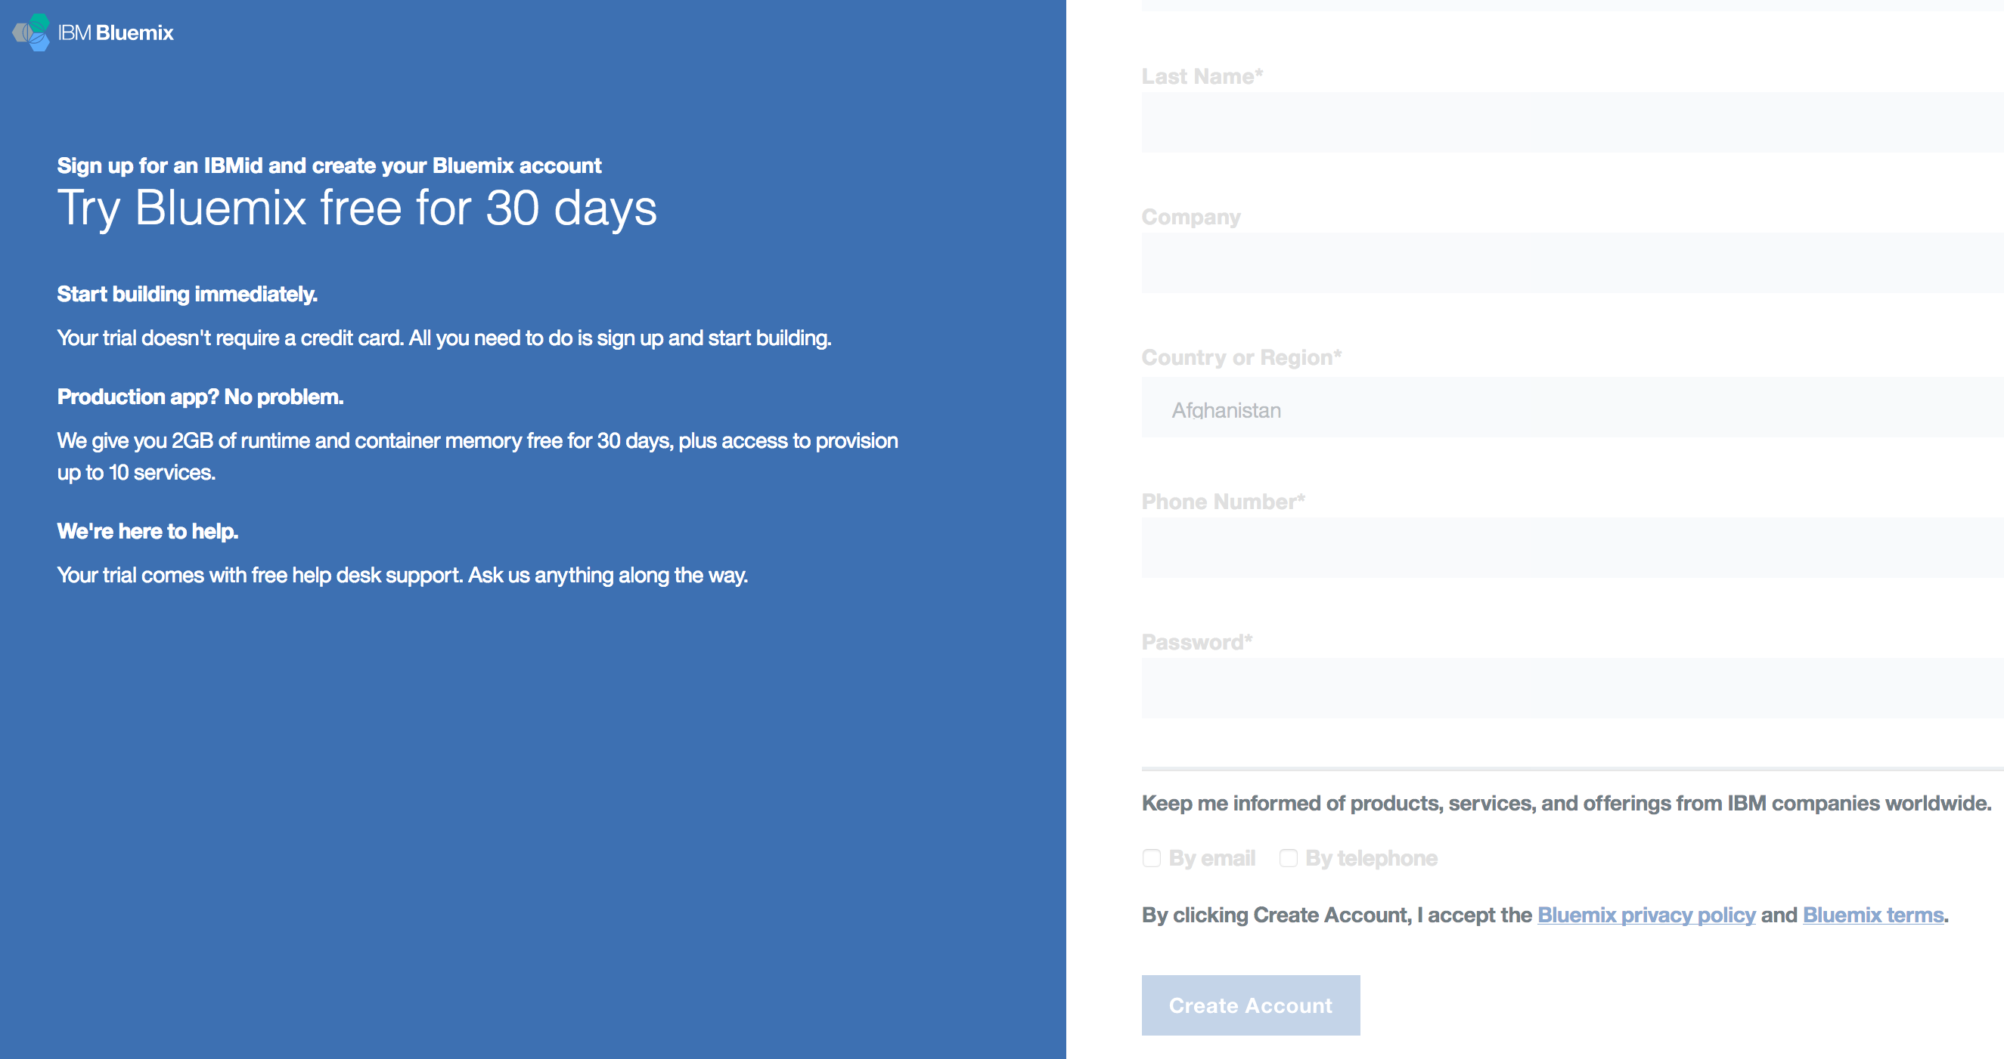After completing the required fields of the form and entering your email address, click on ‘Create Account’.
   3. 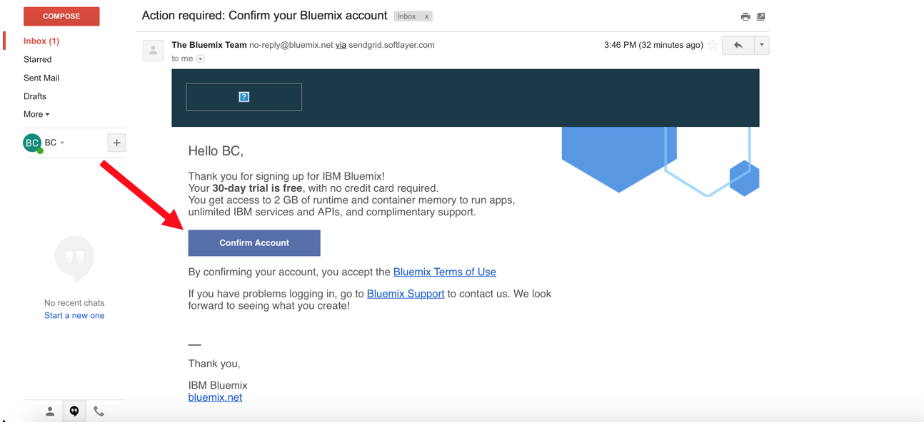Check your email for a note to confirm your IBM Cloud account. Click on the ‘Confirm Account’ button and you will be redirected to the login page.
2. Logging in to IBM Cloud Account  
   1. 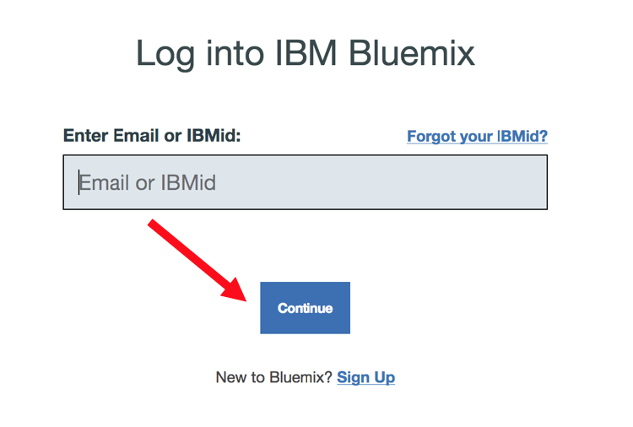Log in to your IBM Cloud account using your email address. If you do not already have an IBM Cloud account, please refer to the ‘Creating an IBM Cloud Account’ steps.
3. Setting Up Your Environment in IBM Cloud  
   1. 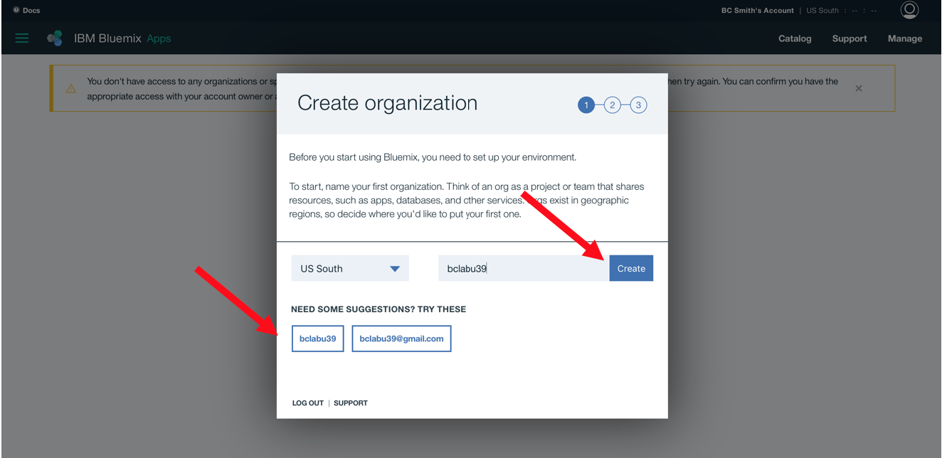When you log into IBM Cloud for the first time, you will be prompted to ‘Create organization’. Here you can select the suggested organization below and then click the ‘Create’ button.
   2. 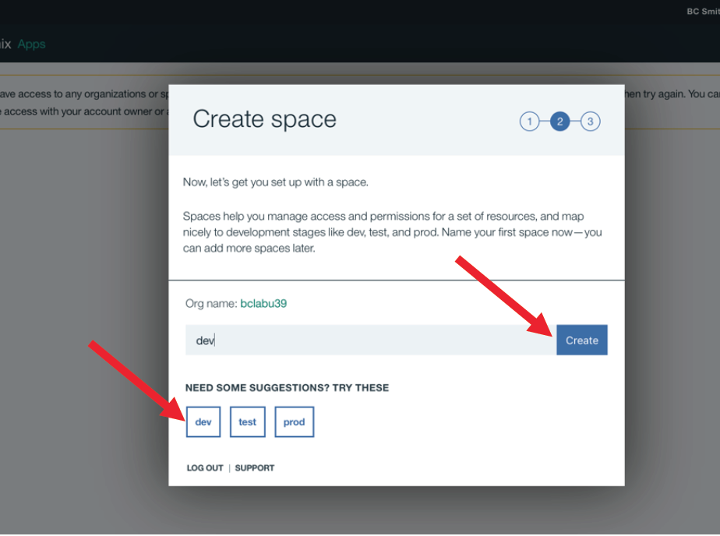Then you will ‘Create space’. Select the ‘dev’ space and then click on the ‘Create’ button.  
        
        
        
        
        
        
        
        
        
        
        
        
        
        
        
        
        
      You have successfully setup your IBM Cloud environment to start working on this lab. Click on the ‘I’m Ready’ button.
4. Create a Spark service  
   1. 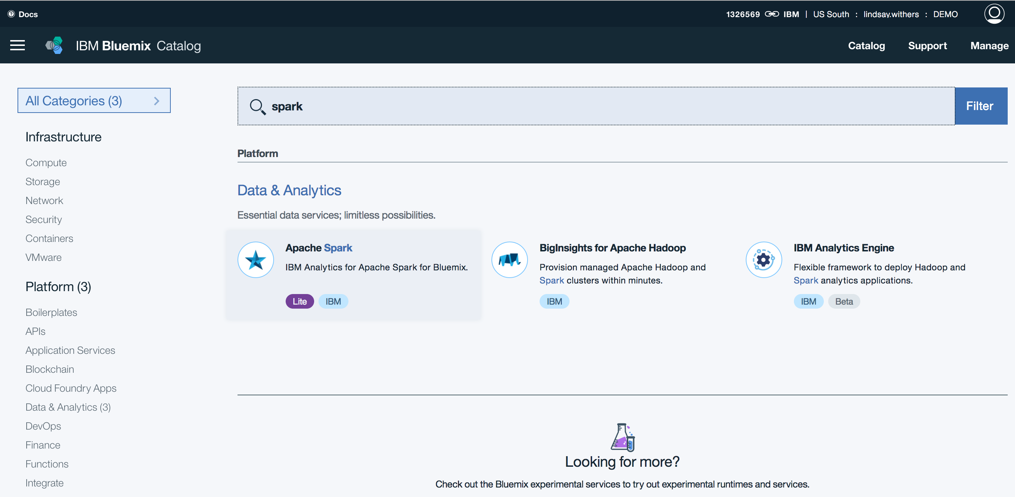Navigate to the IBM Cloud Catalog  
        
      - Search ‘Spark’ in the search box  
      - Select the Apache Spark service under Data & Analytics
   2. 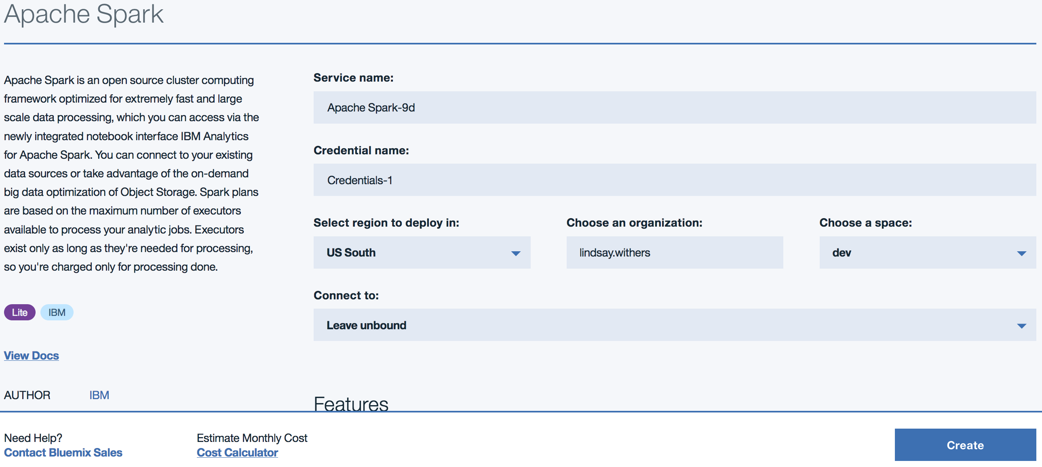Name the service and make sure the region, organization and space align with the setup from steps 3a and 3b  
        
      - Make sure the ‘Lite’ pricing plan is selected and click ‘Create’
5. Create a Machine Learning service  
   1. 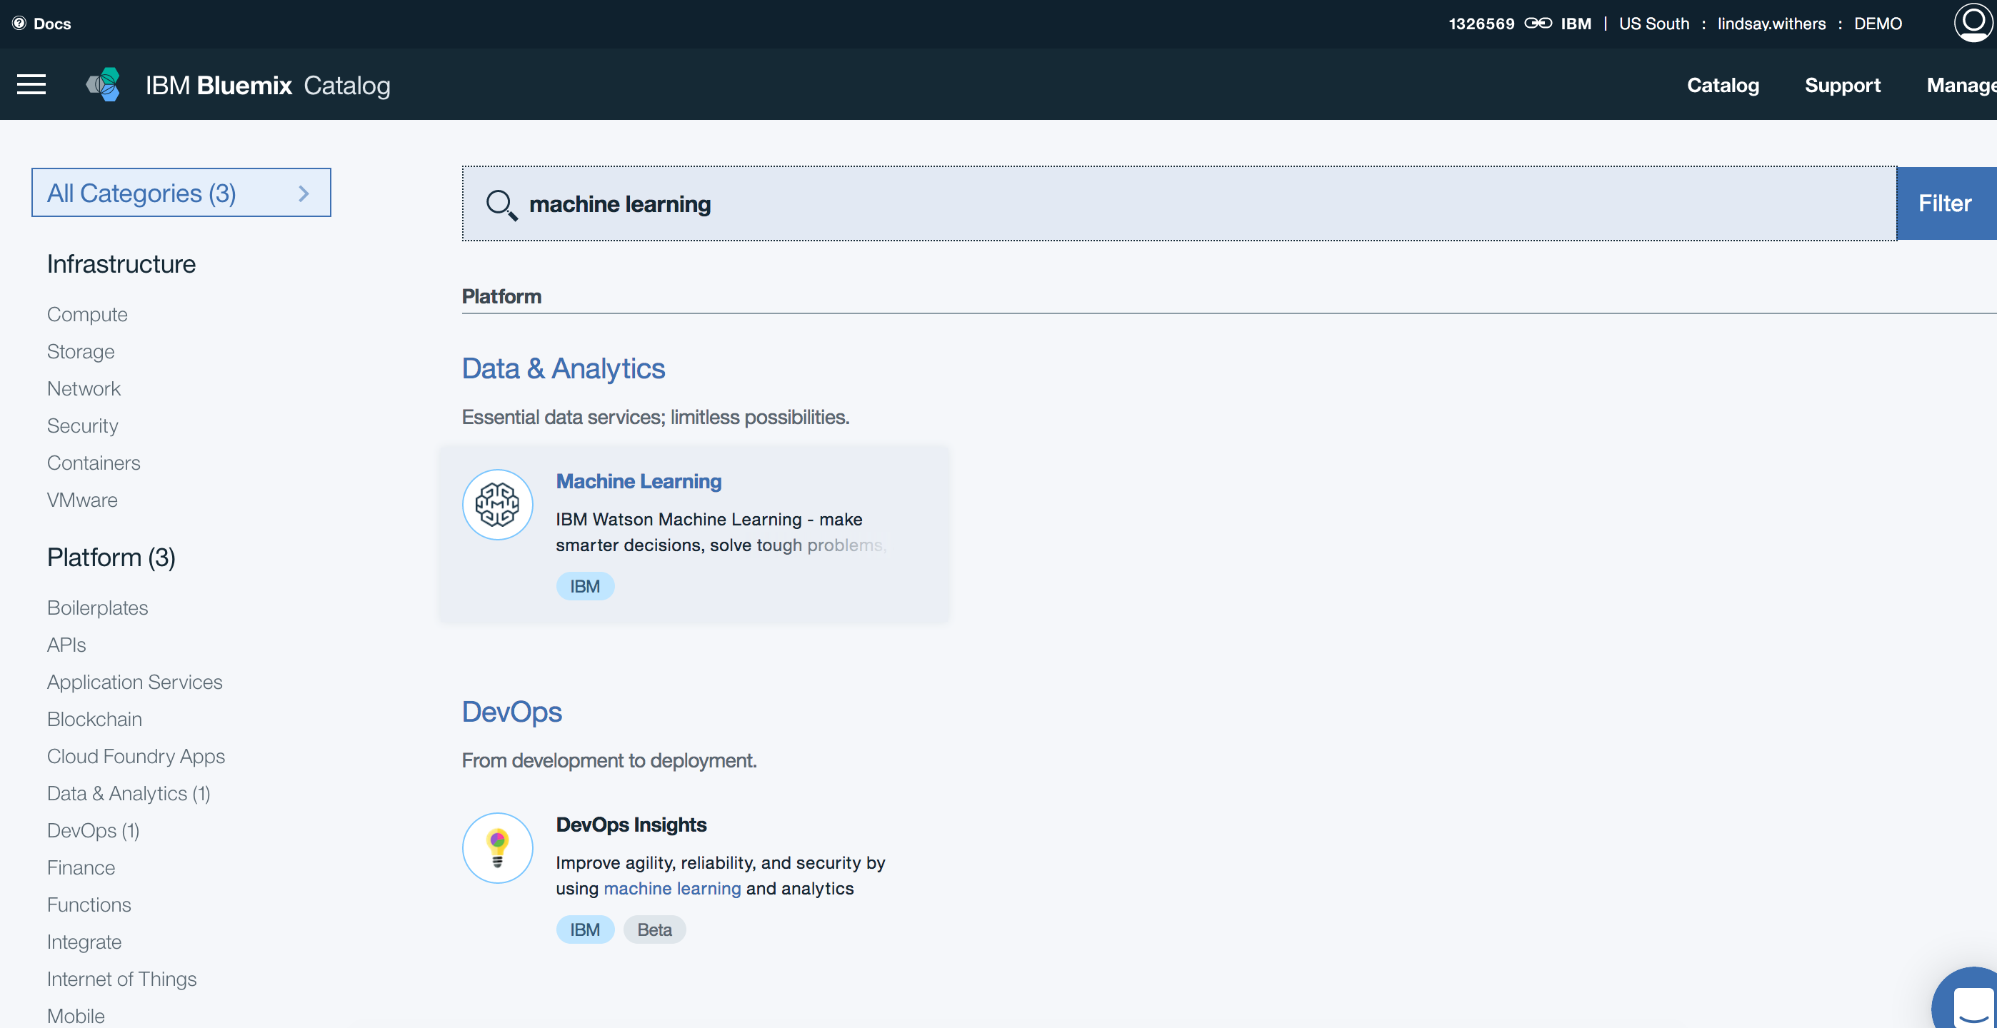Navigate back to the IBM Cloud Catalog  
        
      - Search ‘machine learning’ in the search box  
      - Select the Machine Learning service under ‘Data & Analytics’
   2. 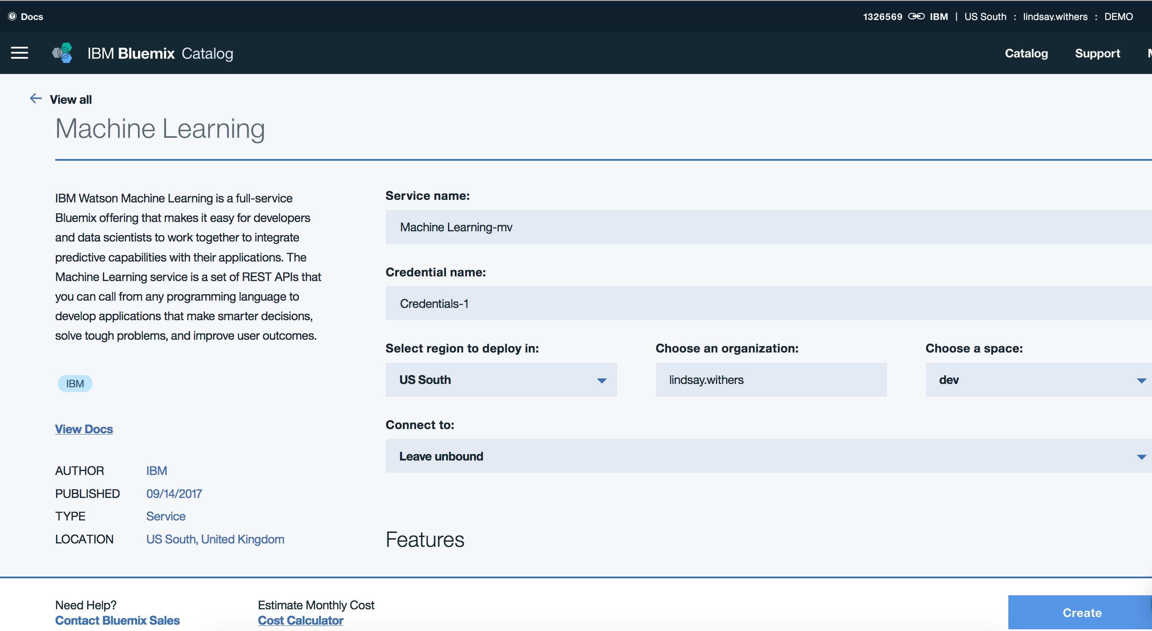Repeat step 4b to name your Machine Learning service, and make sure the region, organization and space are correct  
        
      - Make sure the ‘Lite’ pricing plan is selected and click ‘Create’
6. Setup your IBM Data Science Experience (DSX) environment  
   1. Navigate to <http://datascience.ibm.com> and login using your IBM Cloud userid

**Lab 0 – Data Science Experience Fundamentals**

Data Science Experience (DSX) provides you with the environment and tools to solve your business problems by collaboratively analyzing data. This illustration shows how the architecture of DSX is centered around the **project**. A project is how you organize your resources for solving a business problem.

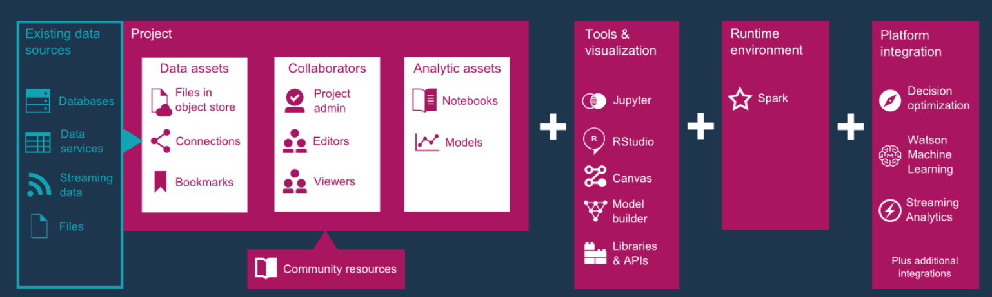

**Projects**

When you create a project for analyzing data, you associate it with a compute engine and storage. Then, you add collaborators, data assets, and analytic assets to your project. You can also add bookmarks to important resources and associate other services with your project.

Here's what a project looks like:

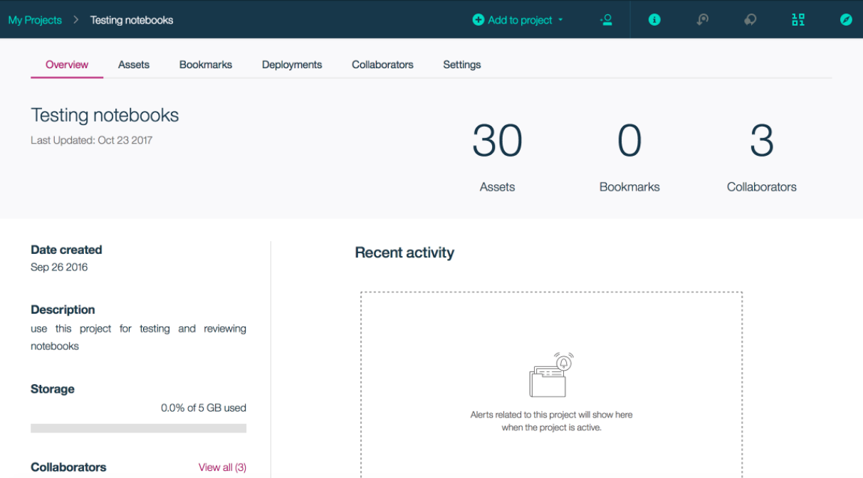

**Data Assets**

You can analyze data from the following sources:

* You can load files from your local computer to use in notebooks and models.
* You can create connections to these kinds of data sources:
  + Cloud data services, such as Db2 Warehouse on Cloud, Amazon S3, Cloudant, PostgreSQL
  + On-premises databases, such as Db2, Netezza, Oracle, and SQLServer
  + Streaming data services, such as IBM MessageHub and IBM Streaming Analytics
* You can use DSX Community data sets.

**Tools**

You can analyze data with these tools:

* You can write Jupyter notebooks in Python, Scala, or R.
* The Flow Editor guides you through creating models that use machine learning for predictive analytics.
* You can use Rstudio within DSX as an alternative to running R notebooks.

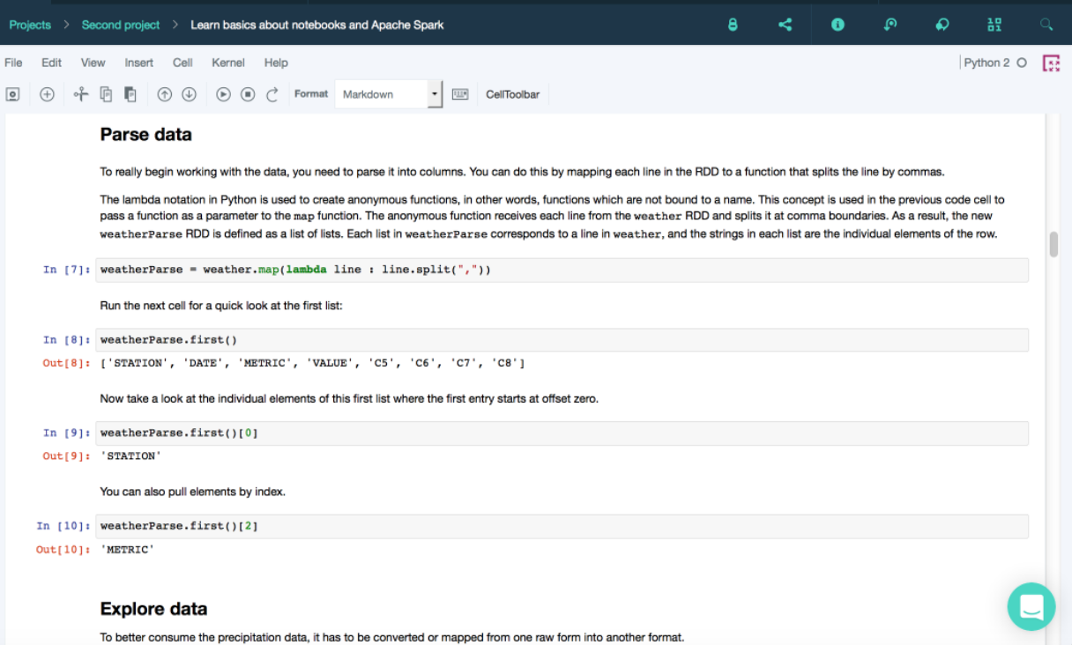Here's what a notebook looks like:

1. Log into DSX <https://datascience.ibm.com/>
2. 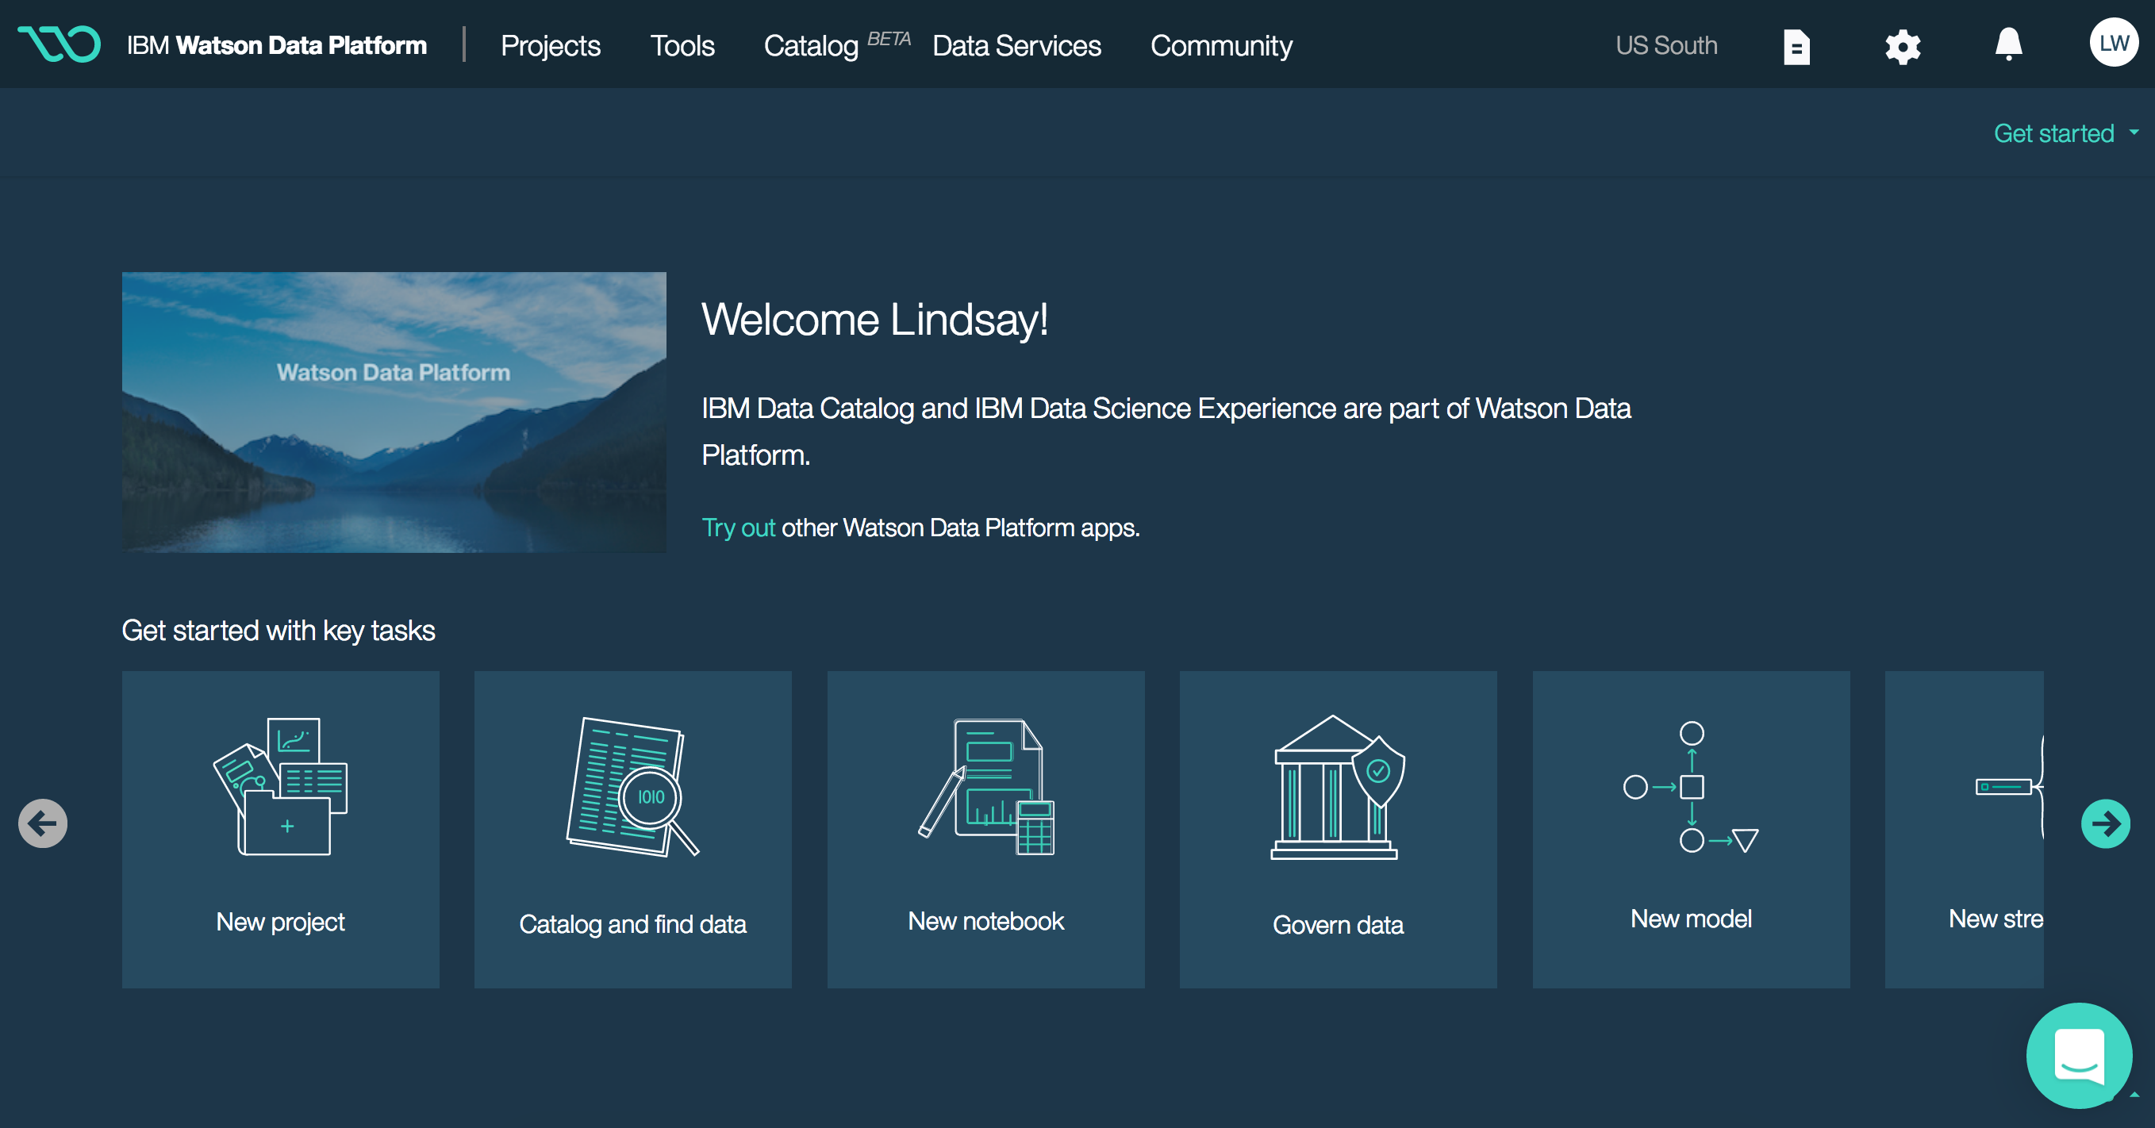Click ‘New Project’
3. 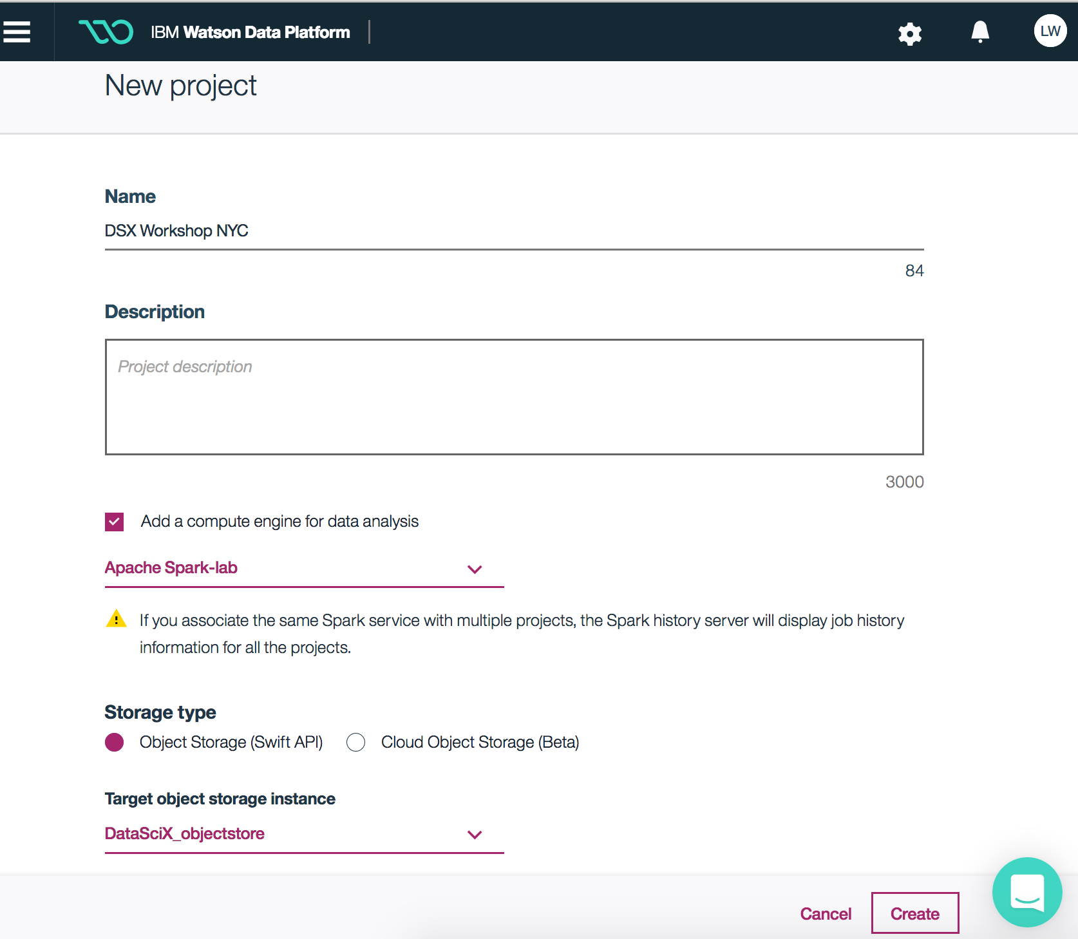Give your project a name (this is the project you will be working in for the duration of the workshop).  
     
   - Under where it says ‘Add a compute engine for data analysis’, select the Apache Spark service that you created in the environment setup portion of the workbook.   
     
   - When you’re ready, click ‘Create’
4. 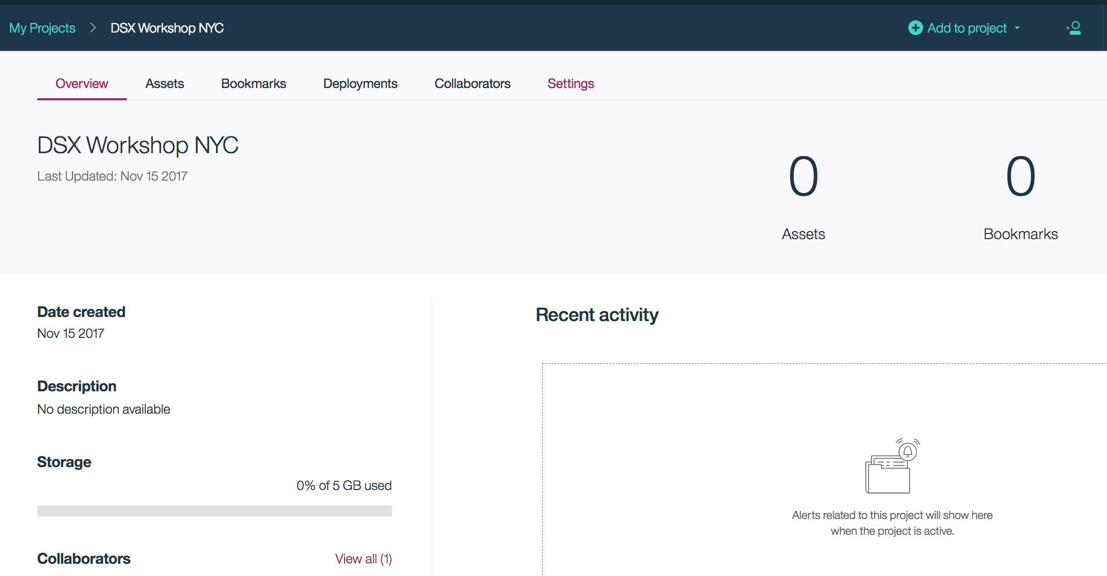Once inside your project, navigate over to the ‘Settings’ tab across the top to associate your Watson Machine Learning service to the project.  
     
     
     
     
     
     
     
     
     
     
     
     
     
   1. 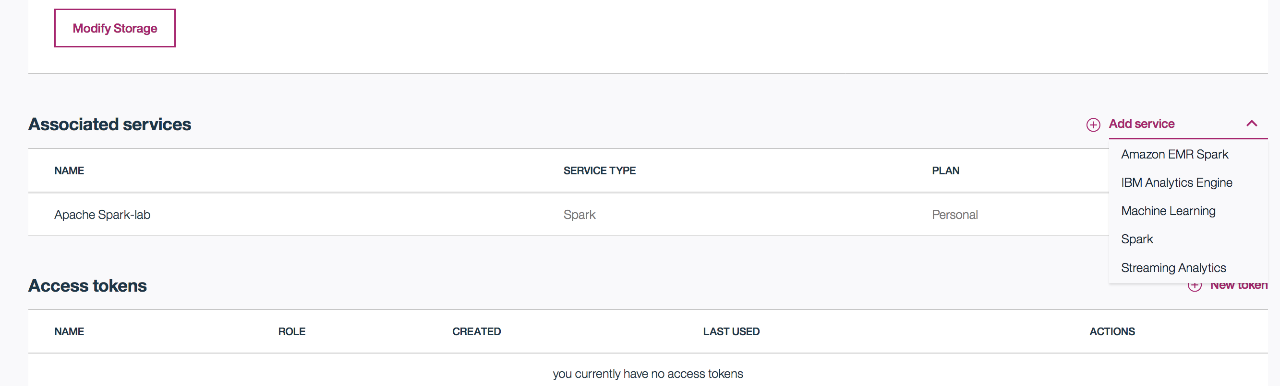Scroll down to where it says ‘Associated Services’. Notice your Spark service is listed. Click ‘Add service’ and select Machine Learning from the drop down of options.
   2. 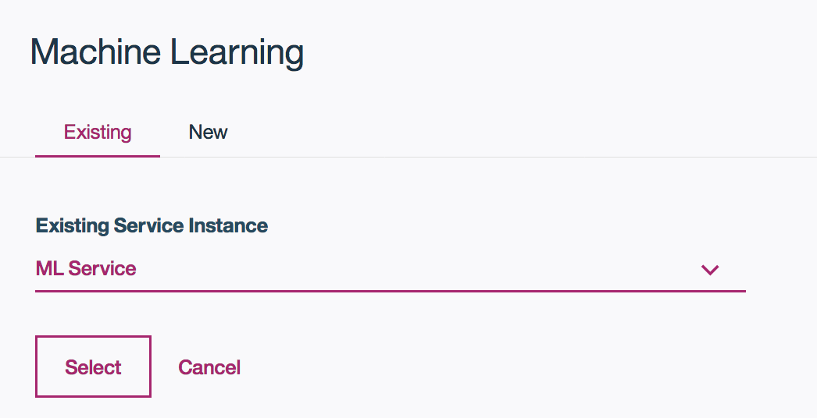From the ‘Existing’ tab, select the Machine Learning service from the drop down that you created in the environment setup section.

**You have now created a project in DSX that leverages Apache Spark as a compute engine, and Watson Machine Learning for deploying models in the cloud. Now we are ready to get hands on with the tools!**

**Summary**

For seamless collaboration between data scientists, DSX enables users to not only share data and analytics assets within the project, but also to share underlying services such as Spark. Data scientists waste huge amounts of time because computational environments aren’t currently shared by default. We believe that data scientists shouldn’t need to make sure that they are running the same version of a Python library as their colleague in order to execute the same code, so we’ve made it possible to share the underlying service in the project.

**Lab 1 – Build a Random Forest Model with Model Wizard**

The focus of this lab is to explore machine learning within DSX using the Model Builder. The intent of this user interface was to simplify the creation of Machine Learning models using a more intuitive visual builder experience. This approach to model building in DSX is ideal for the business analyst looking to create a predictive model in just a few clicks – avoiding any coding.

*Gartner recently shared a report stating that by 2020 more than 40% of Data Science Tasks will be automated.*

In this lab, we will be using the ‘rides.csv’ dataset that can be found in the lab files (<https://github.com/lindsaywithers/dsx-spark)>. The objective is to create a model that provides theme park ride suggestions given some basic demographic details, the size of the party the guest is exploring with, and relevant weather factors such as heat and rain. With this, we can improve the guest experience at each point in their journey as they travel through the park – guiding them from ride to ride.



**Lab duration**: 30 min

**Audience**: Data Scientist, Business Analyst

**Capabilities**: Watson Machine Learning, Data Modeling

**Prerequisites**: Lab 0

1. 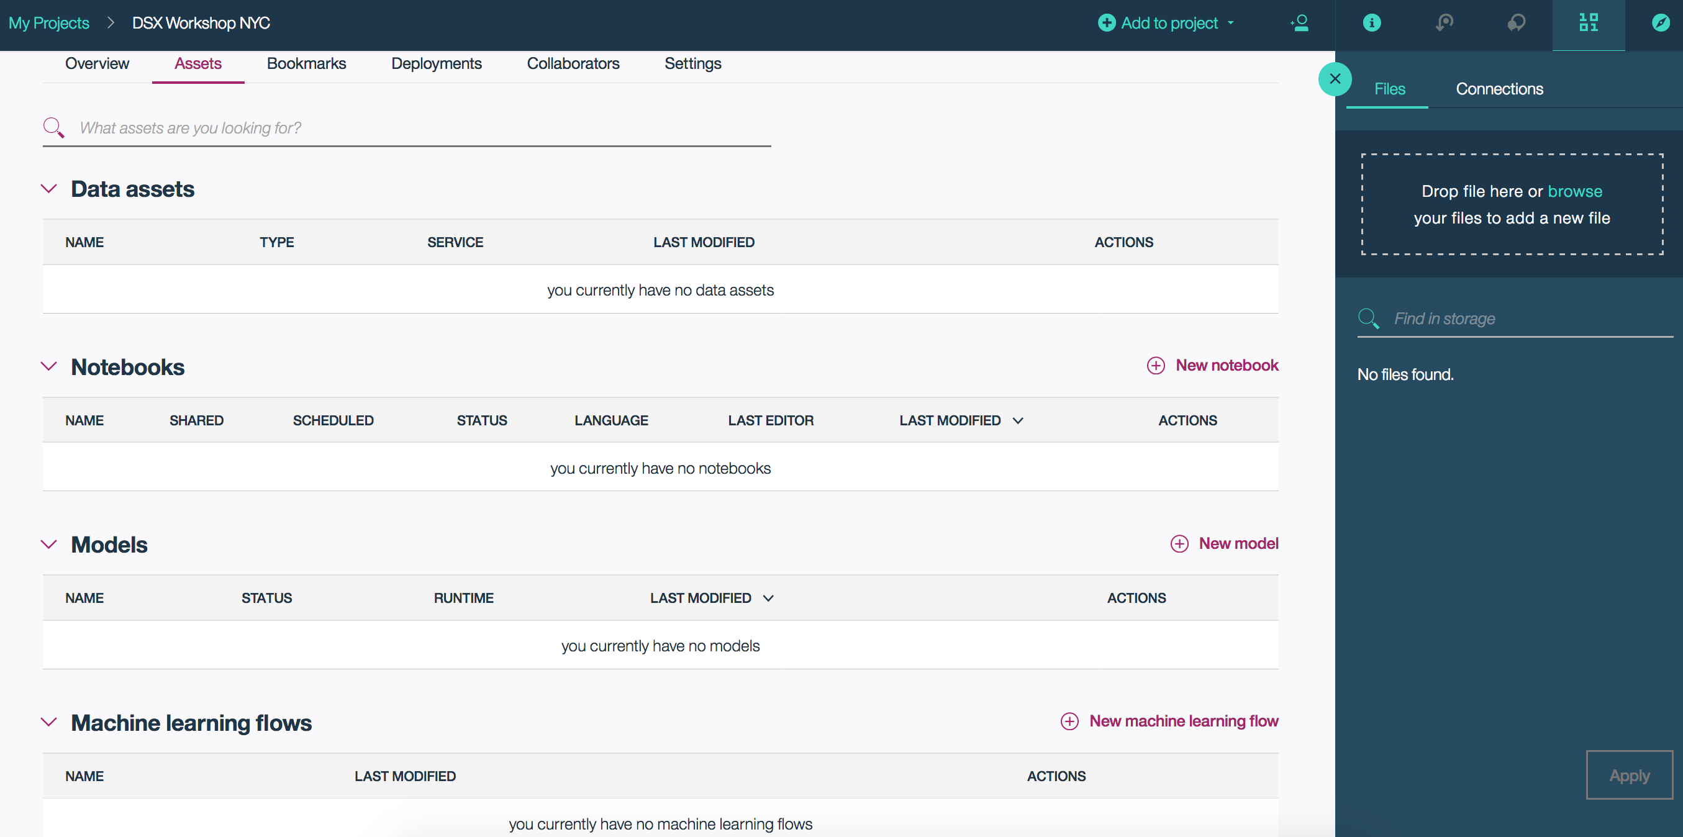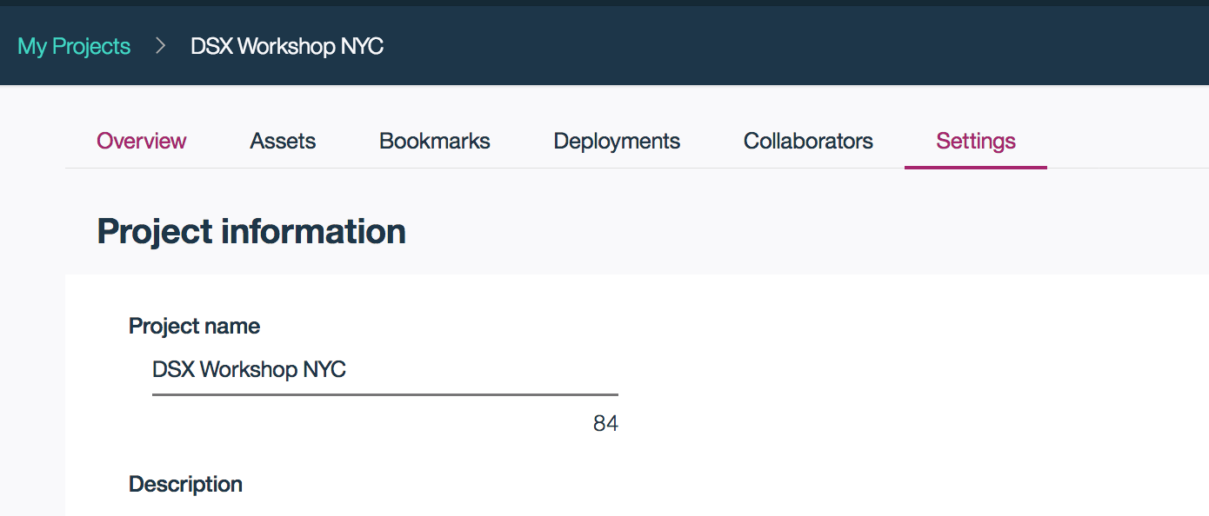Navigate to the ‘Assets’ tab of your project  
     
     
     
     
     
     
     
     
     
     
     
     
     
     
     
     
     
     
     
     
     
     
     
     
   *In ‘Assets’ you will be able to add and manage data assets, notebooks, models and machine learning flows within your project.
2. Create a random forest model using the Model Builder.  
   1. 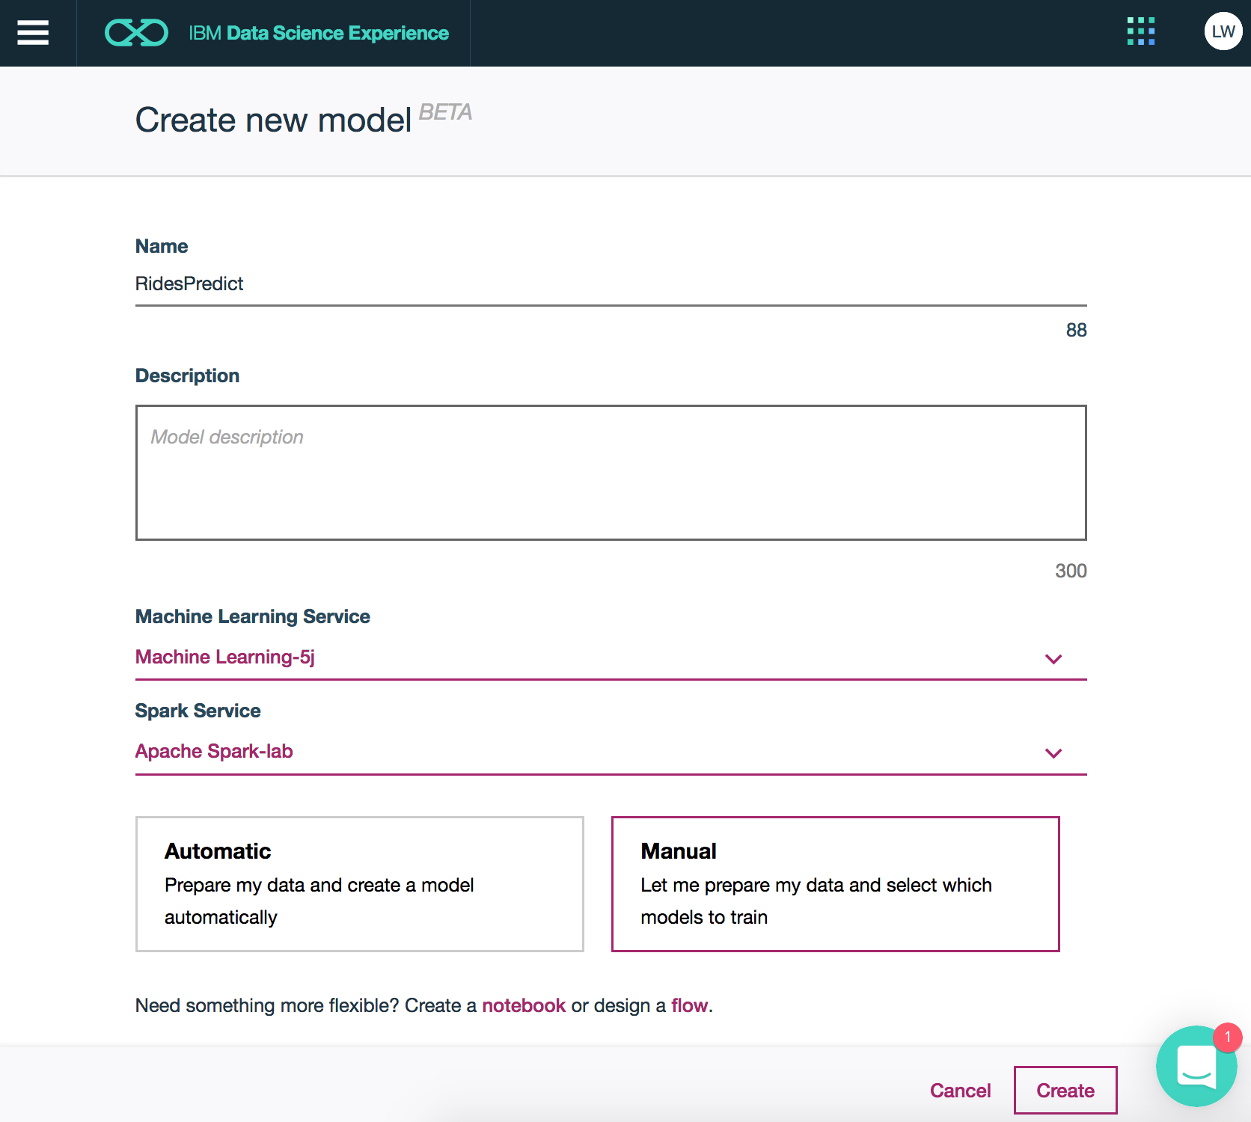Click ‘add models’  
        
      - Give your model a name, choose **Manual**, and click ‘Create’
   2. Navigate back to the Github Repository which has our lab files:  
      <https://github.com/lindsaywithers/dsx-spark>
   3. Download the rides_3.csv file from the repository by clicking on the file, right-click ‘Raw’ and save the CSV to your desktop
   4. 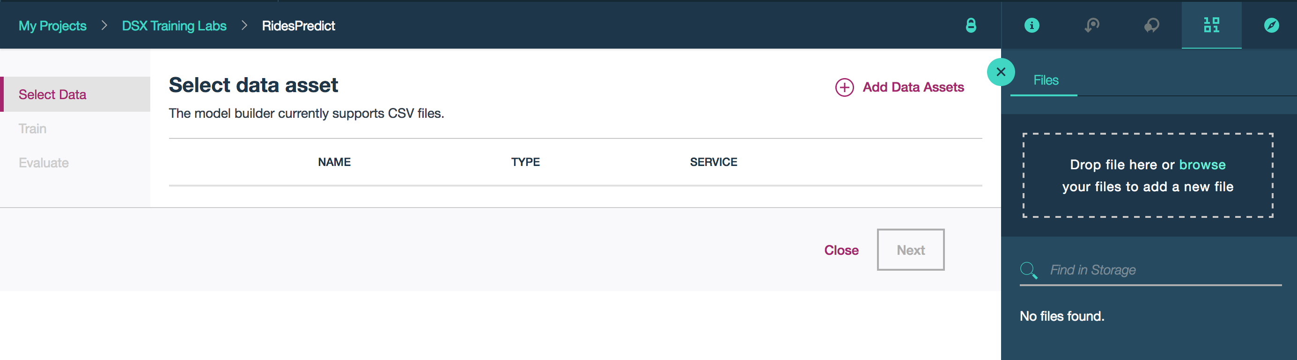Back to DSX, browse and select the rides file you just saved to bring into the project as a data asset

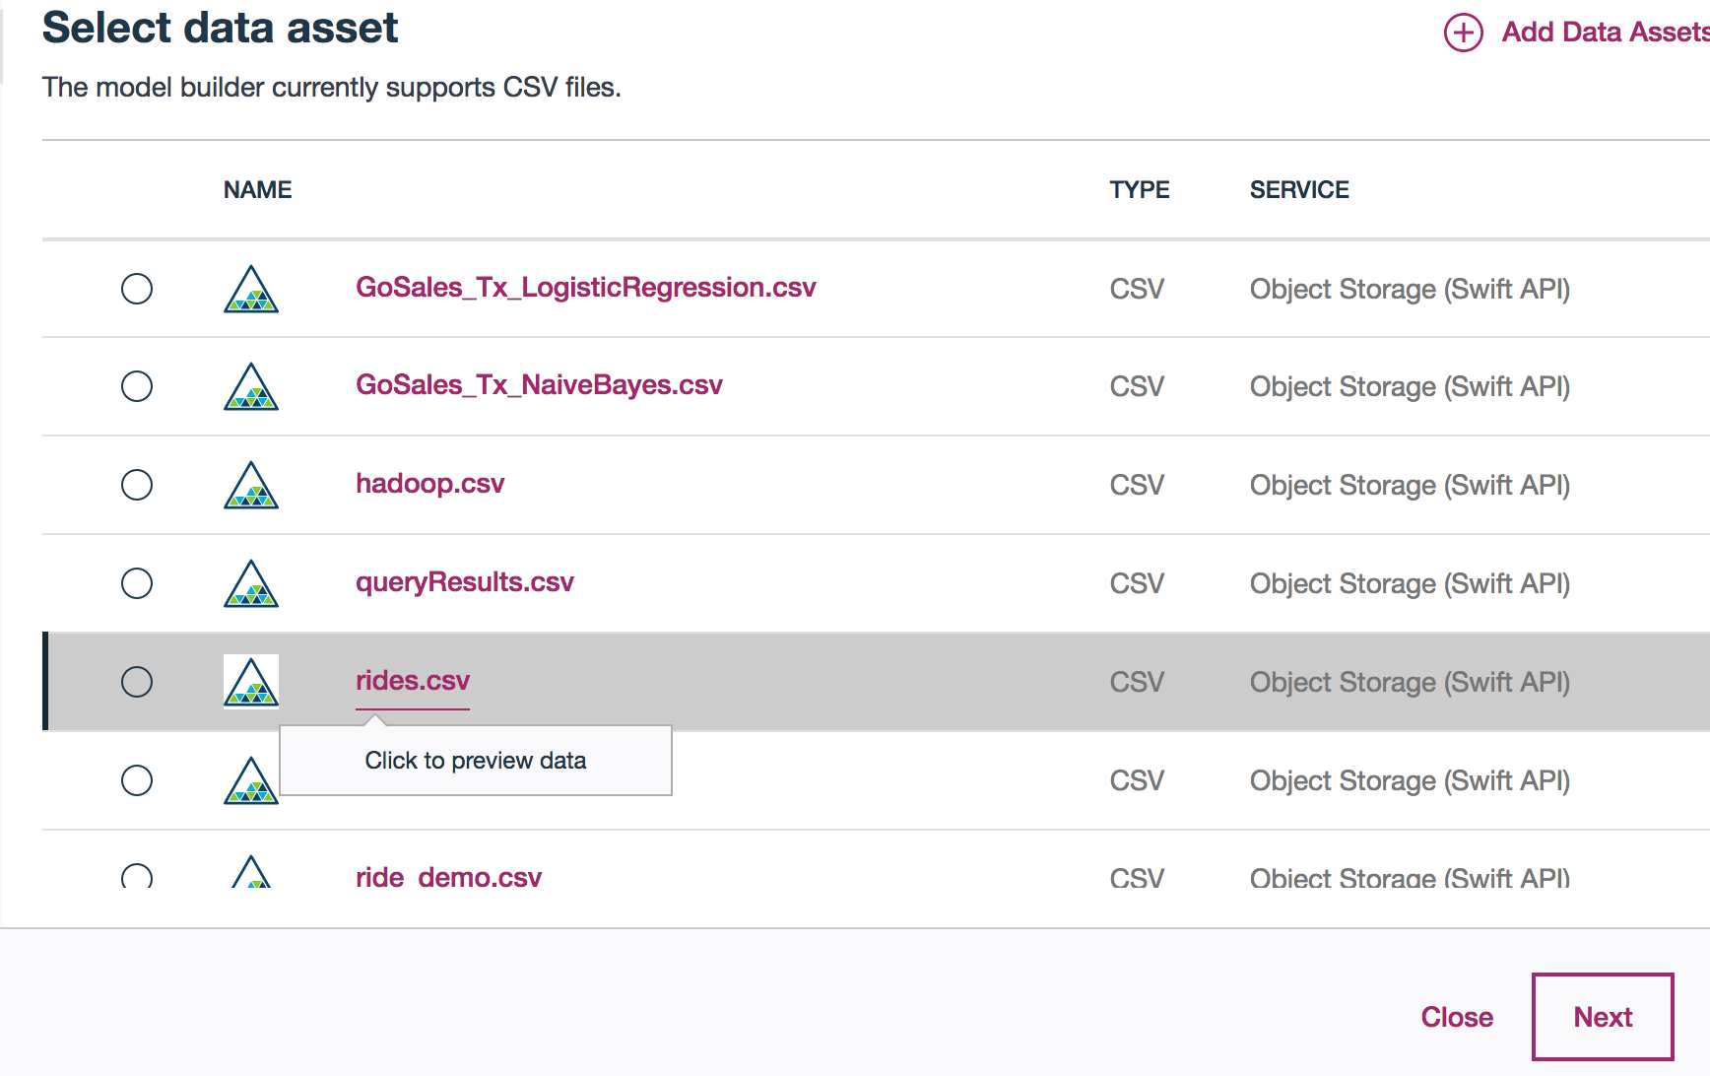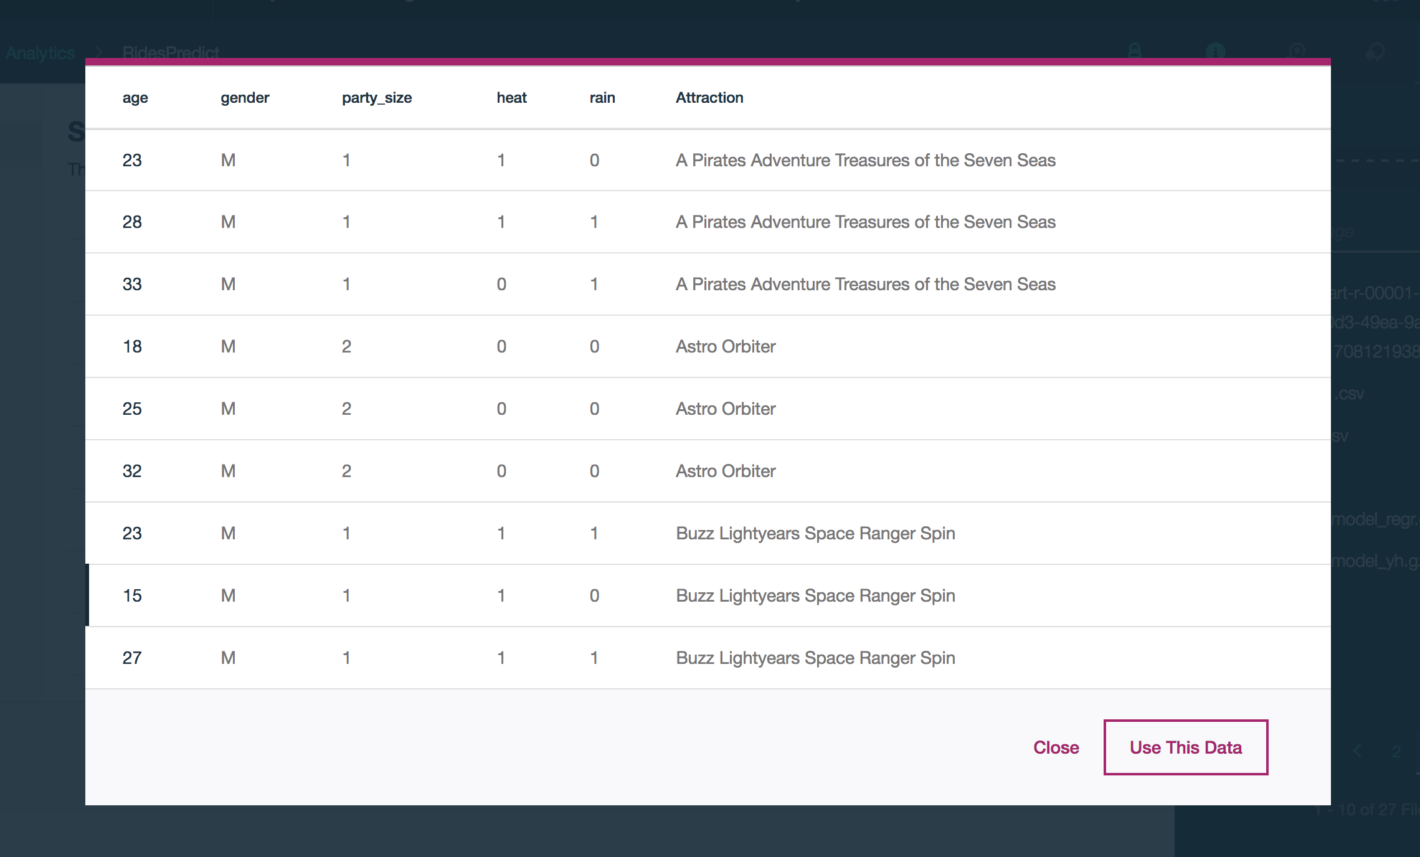Notice that once your files have been added to the project as a data asset, you have the ability to preview the data before loading it in (hover over the file):  
  
  
  
  
  
  
  
  
  
  
  
  
  
  
  
  
  
  
  
  
  
  
  
  
  
Once you are confident you have the dataset you want, click ‘Use This Data’.

* 1. 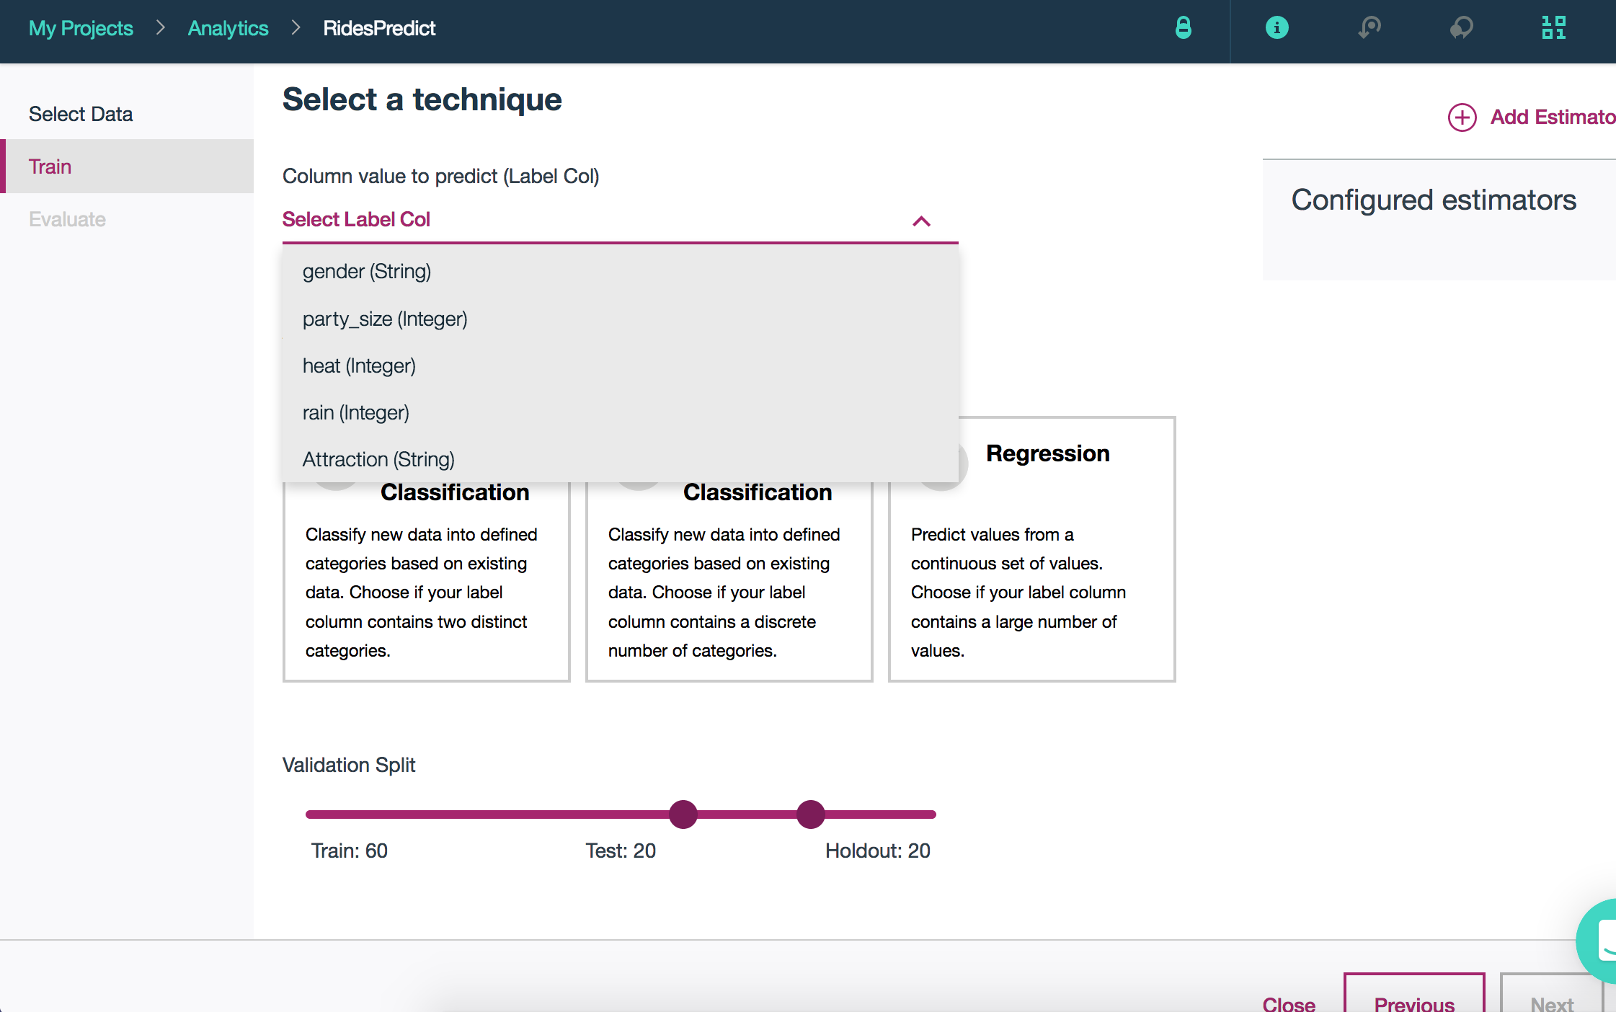Select the ‘Attraction (String)’ as your label column  
       
     Attraction will be our label for this model since it is the value that we are trying to predict.  
       
       
       
       
       
       
       
       
       
       
       
       
       
     For our feature columns, we will leave all as the default since it will be useful to have each as an input for the model.
  2. 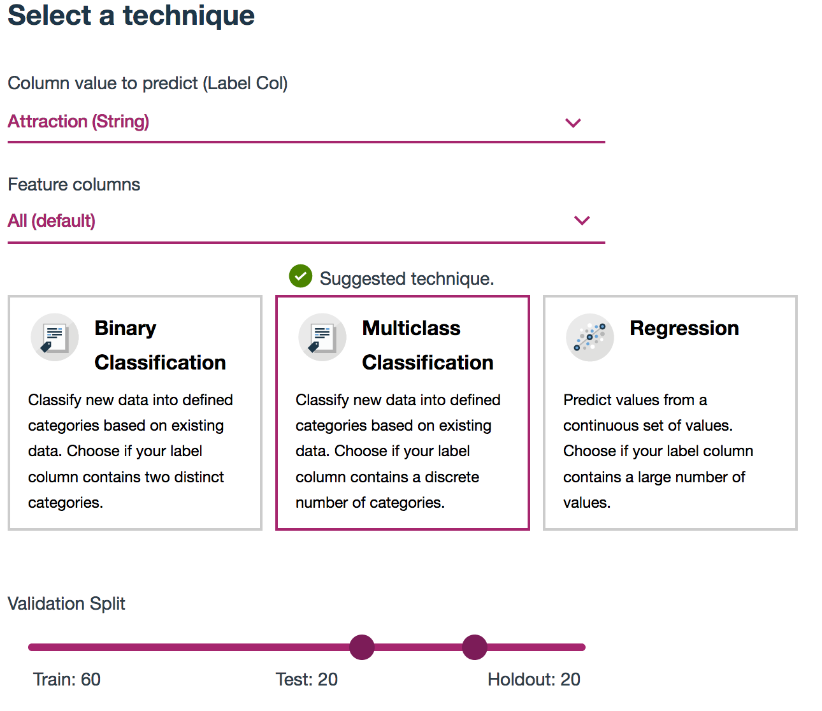Select ‘Multiclass Classification’ as the technique  
       
     Note: After setting your label and feature columns, DSX will guide your next decision by providing a suggested technique.
  3. Click ‘**Add Estimators**’ from the upper right hand corner of the screen
  4. 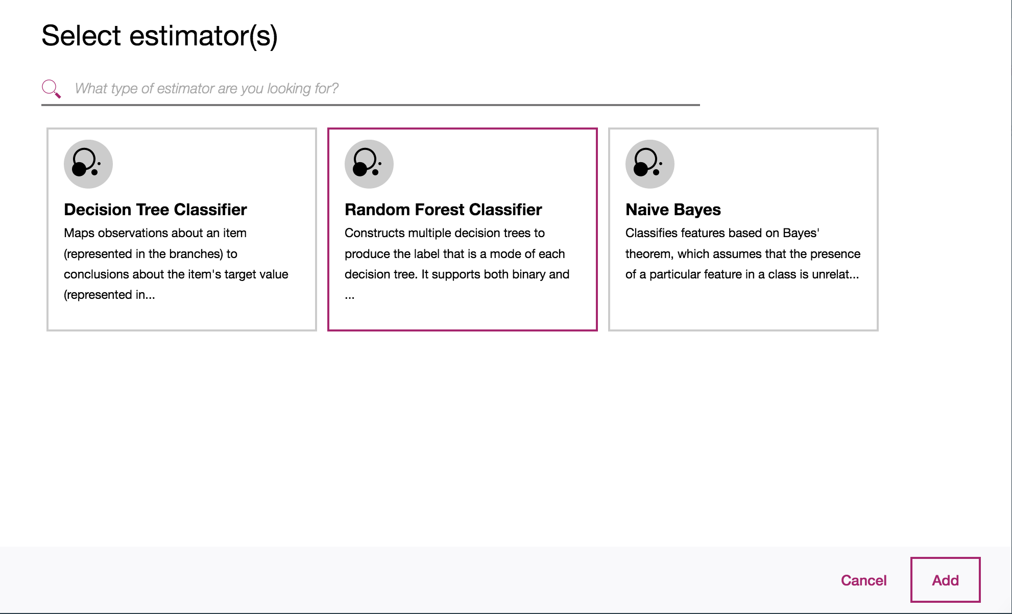Select the ‘Random Forest Classifier’ and click ‘Add’
  5. 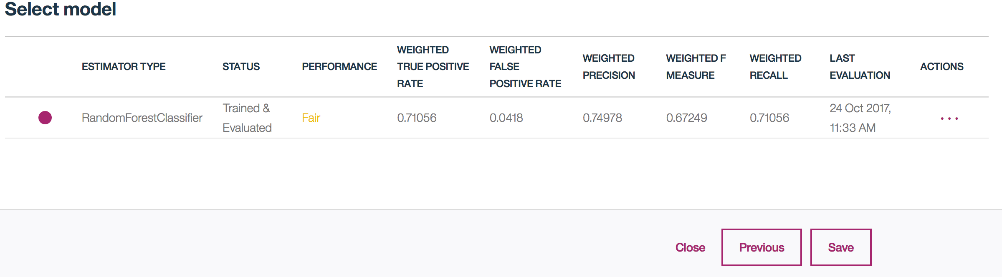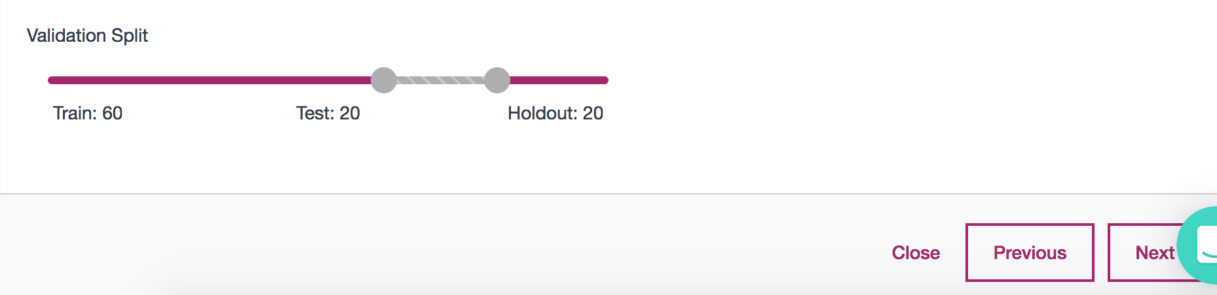Leave the defaults for the Validation Split and click ‘Next’  
       
       
       
       
       
       
       
     **Wait a minute or so while your model is training. When it’s been trained and evaluated, it should look like the following.   
       
       
        
       
       
       
       
       
     Note that performance may show ‘Fair’ but it will still work. The bigger the dataset, the better performance evaluation you will receive (higher accuracy when there is more data to train). ‘Save’ and then click ‘Save’ again.

Once your model is saved, you will be brought to a page displaying the details. This page serves as a useful reference to look back into the model builder details as well as the training and input schemas.

* 1. 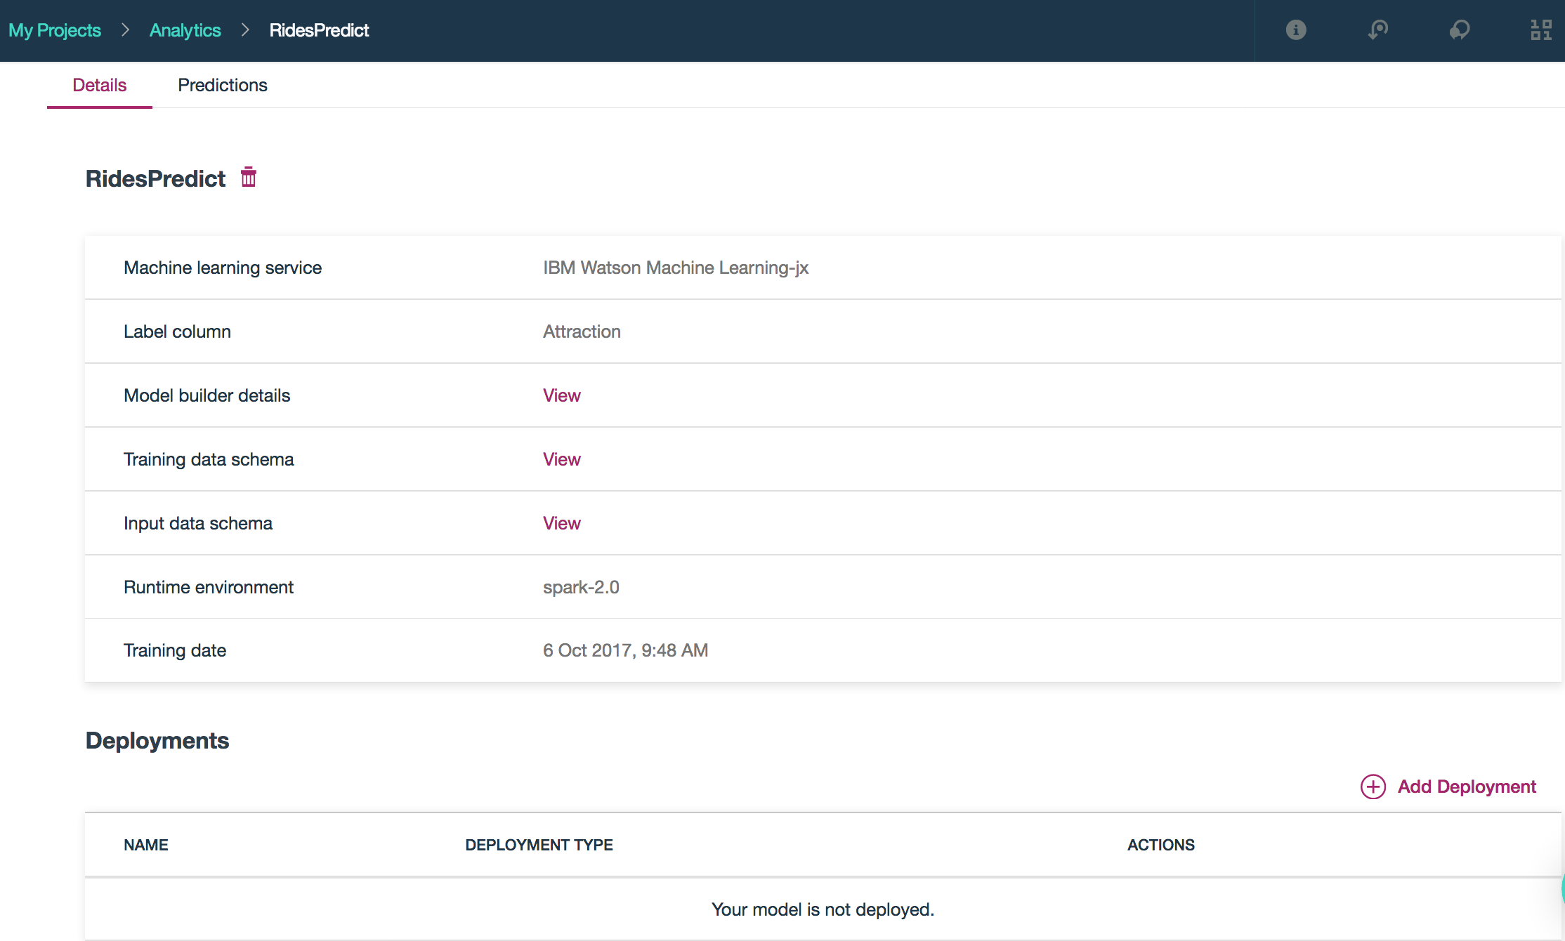Create a deployment by clicking the ‘Add Deployment’ link on the bottom
  2. 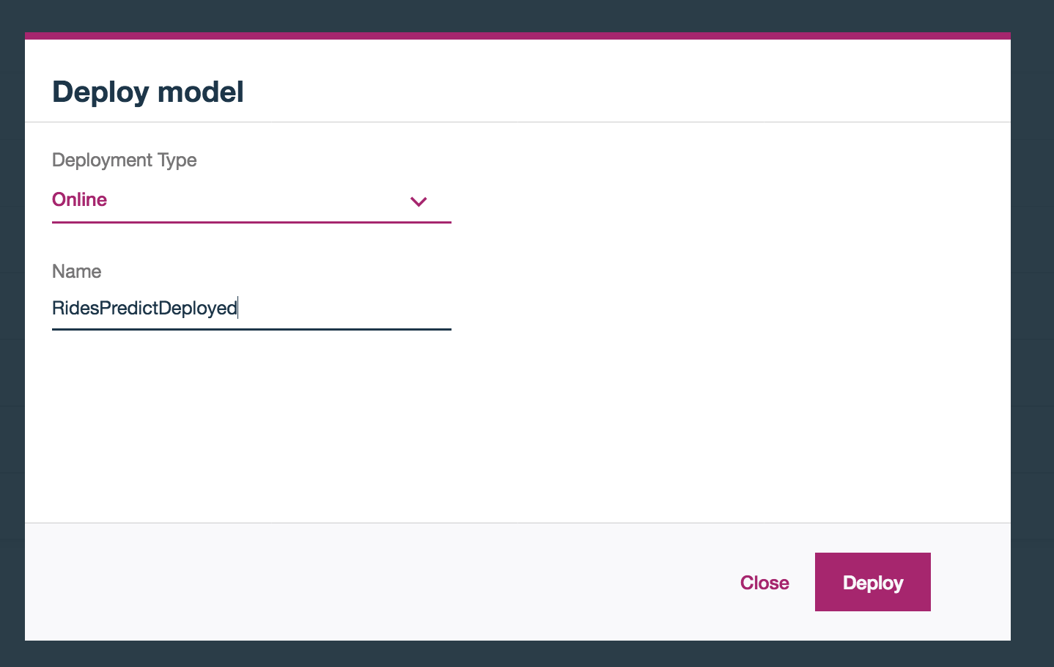Select ‘Online’ as deployment type, name the deployed model and click ‘Deploy’
  3. 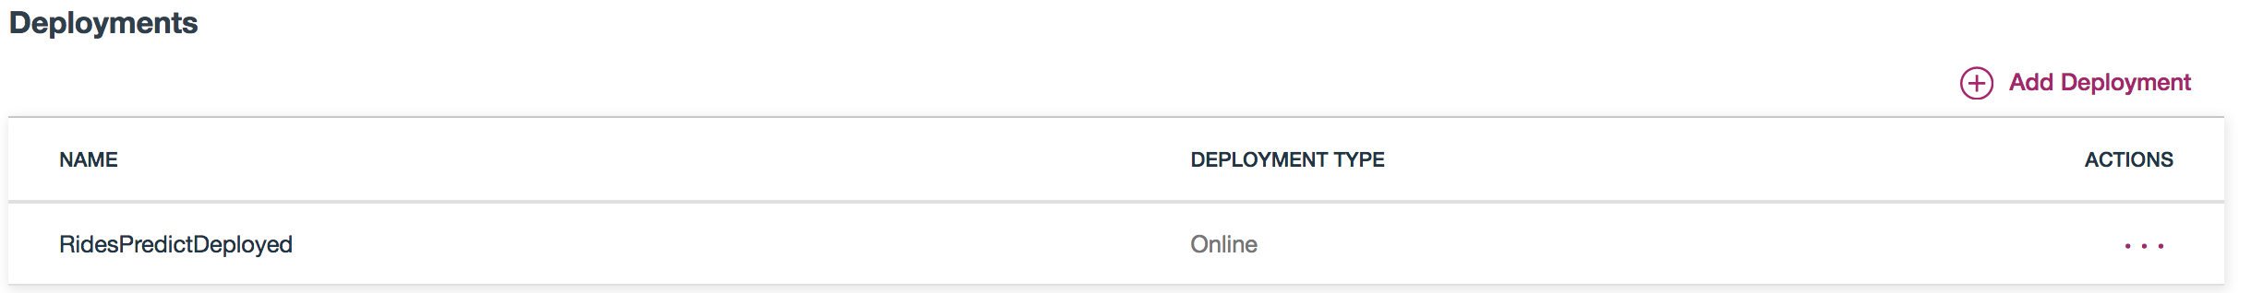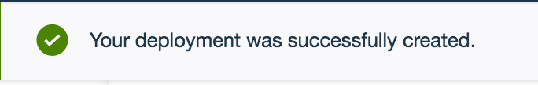Once your model has deployed successfully, click on it from the ‘Deployments’ section

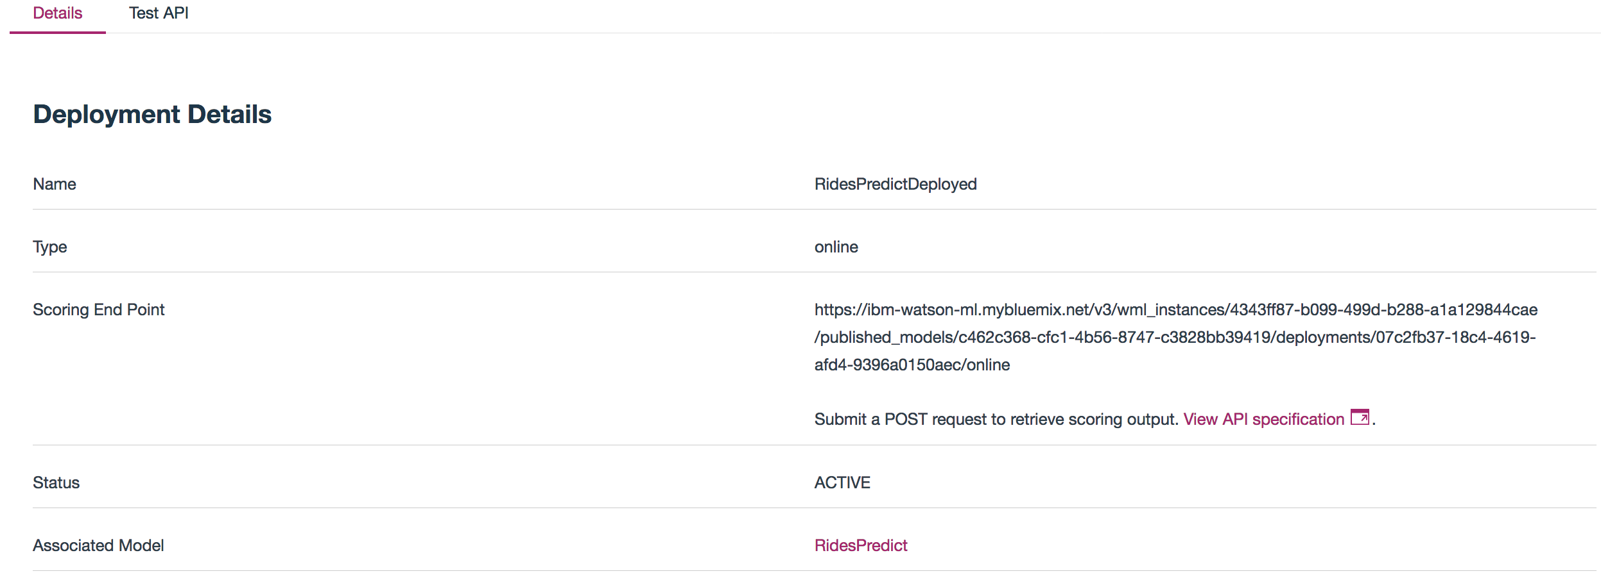The scoring endpoint for your deployed model can be found here in the Deployment Details page.

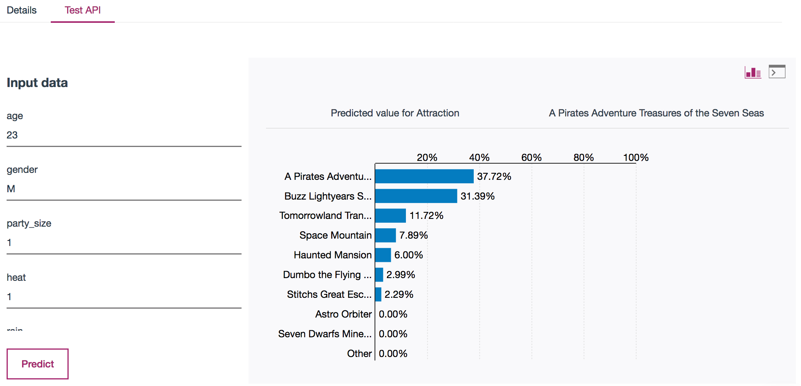  
  
  
  
  
Select the ‘Test API’ tab and click ‘Predict’ to see your model in action!  
  
- Test out different inputs and see how the predicted values for Attraction change  
  
  
  
  
  
  
  
  
  
  
  
**You now have a working Machine Learning endpoint that can predict attractions that will appeal to different audiences in certain weather conditions.**

**Summary**

In Lab 1, we used the model builder to create a predictive model quickly with only a few clicks. This out of the box feature gives the business analyst a chance to experiment with machine learning on their data without having to code a single line. The ability to create and deploy these models within one platform reduces analytic silos, and makes it easier for data professionals to share data products and work together.

**Lab 2 – Build a Random Forest Model using the Flow Editor**

You can create a machine learning flow, which is a graphical representation of data, by using the **Flow Editor** to prepare or shape data, train or deploy a model, or transform data and export it back to a database table or file in object storage. The flow editor in DSX empowers users to do more visual model building. The interface is easy for anyone to learn and use – from business users to data scientists.

In this lab, we will be using the same dataset that we used in Lab 1 (rides_3csv). The data was saved as a data asset in your project, so no need to reload it back in.

**Lab duration**: 40min

**Audience**: Data Scientist, Business Analyst, Data Engineer

**Capabilities**: DSX Flow Editor, Apache Spark, Watson Machine Learning (built in support for SPSS streams)

**Prerequisites**: Labs 0-1

1. Build a random forest model using the Flow Editor in DSX  
   1. Navigate back to the ‘Assets’ section of your project
   2. 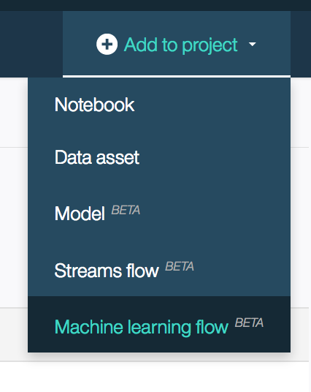Select ‘Add to Project’ from the upper right corner and select ‘Machine Learning Flow’

* 1. On the ‘Create Flow’ page, name your flow and click ‘Create Flow’
  2. 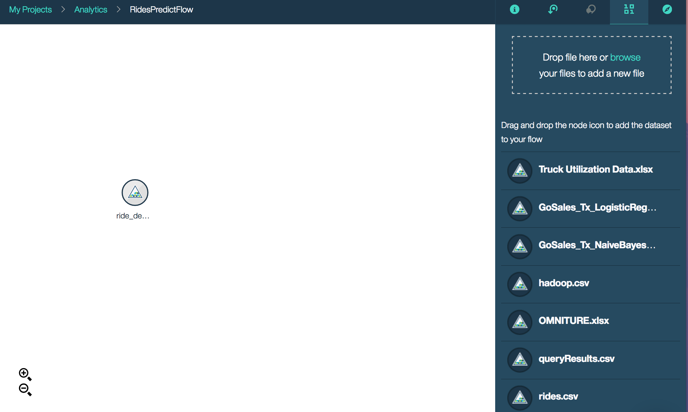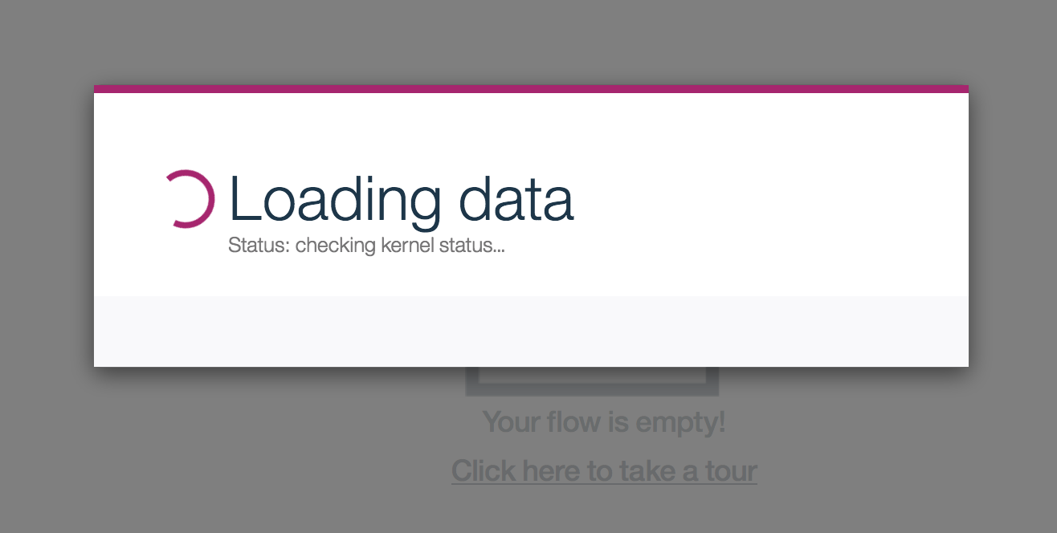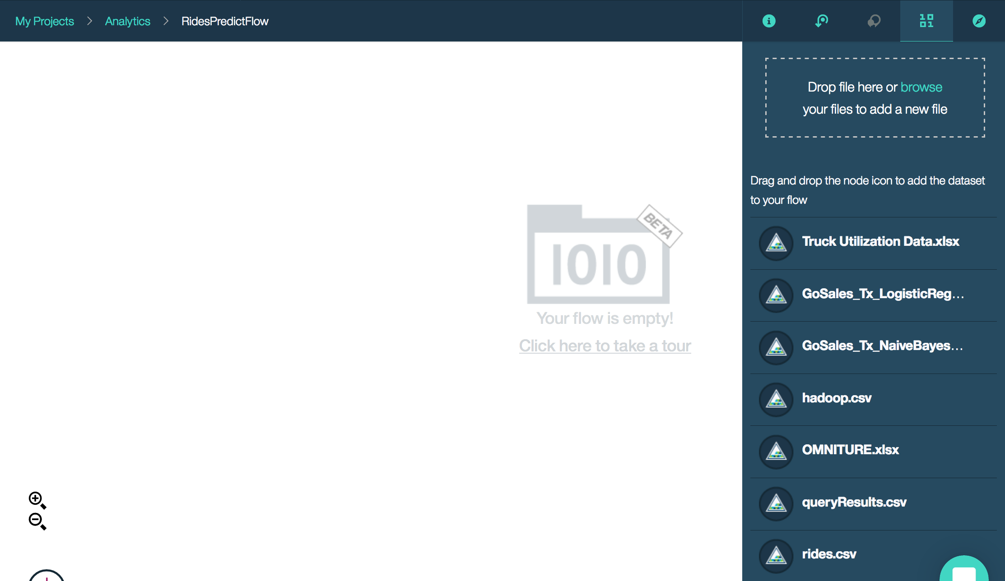Once inside the flow editor, note how simple it is to bring in the rides.CSV dataset by dragging it from the column on the right onto the canvas  
       
       
       
       
       
       
       
       
       
       
       
       
       
     Your data may take a few minutes to be brought into the canvas. You’ll see a message like the one below while it is loading in.  
       
       
       
       
       
       
       
       
     Once it’s loaded, you’ll see an input node with your rides.CSV data in the canvas.

Note that if at any time you lose this data asset sidebar, you can pull it back up by clicking on the ‘1010’ icon in the upper right corner

* 1. 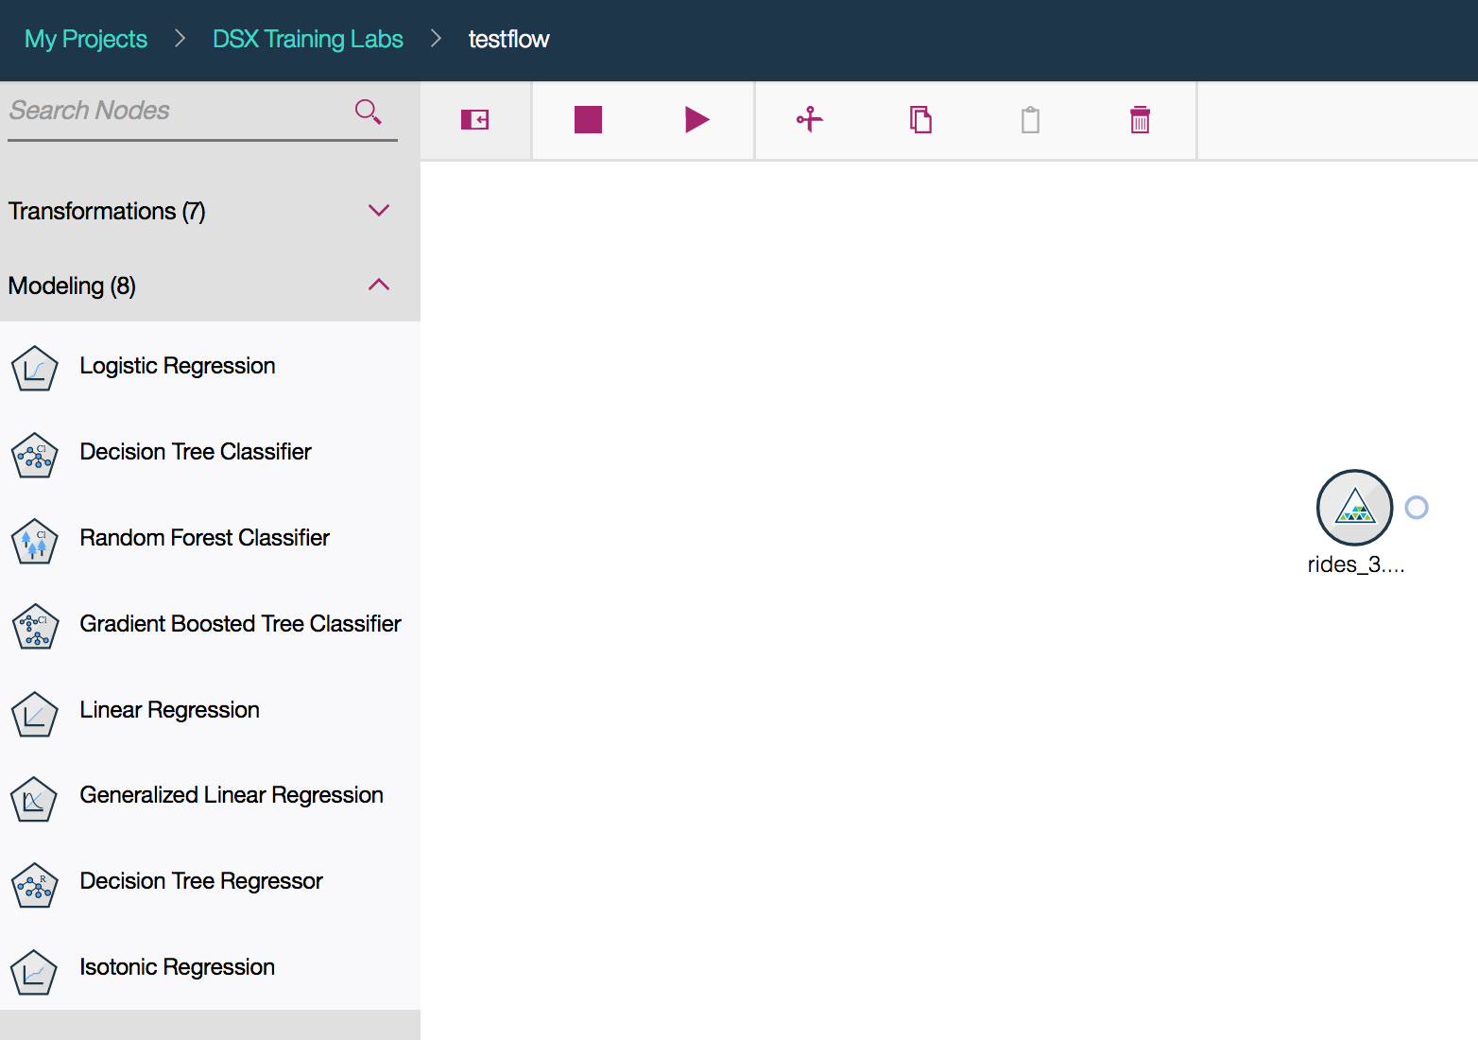Select the palette button in the upper left corner to expand your node palette.
  2. 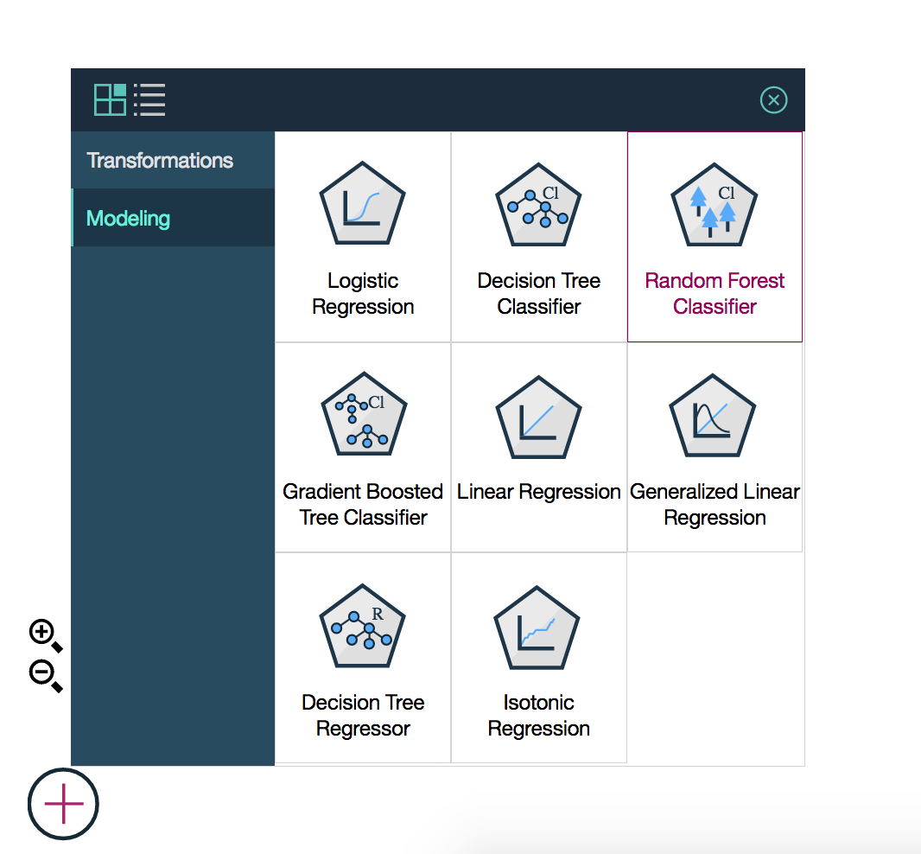Select modeling, and drag the Random Forest Classifier node onto the canvas
  3. 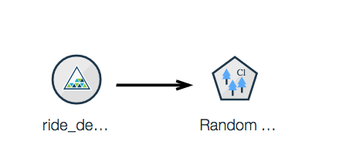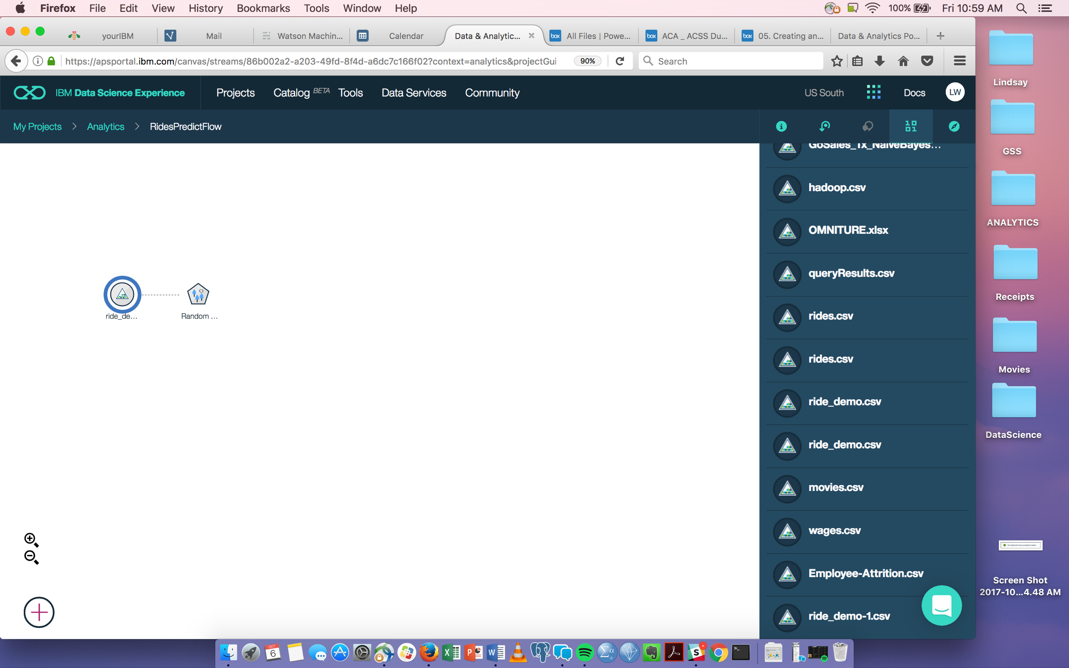Connect the two nodes by hovering over the input node until the circle appears, then click hold and drag your curser to the model node
  4. 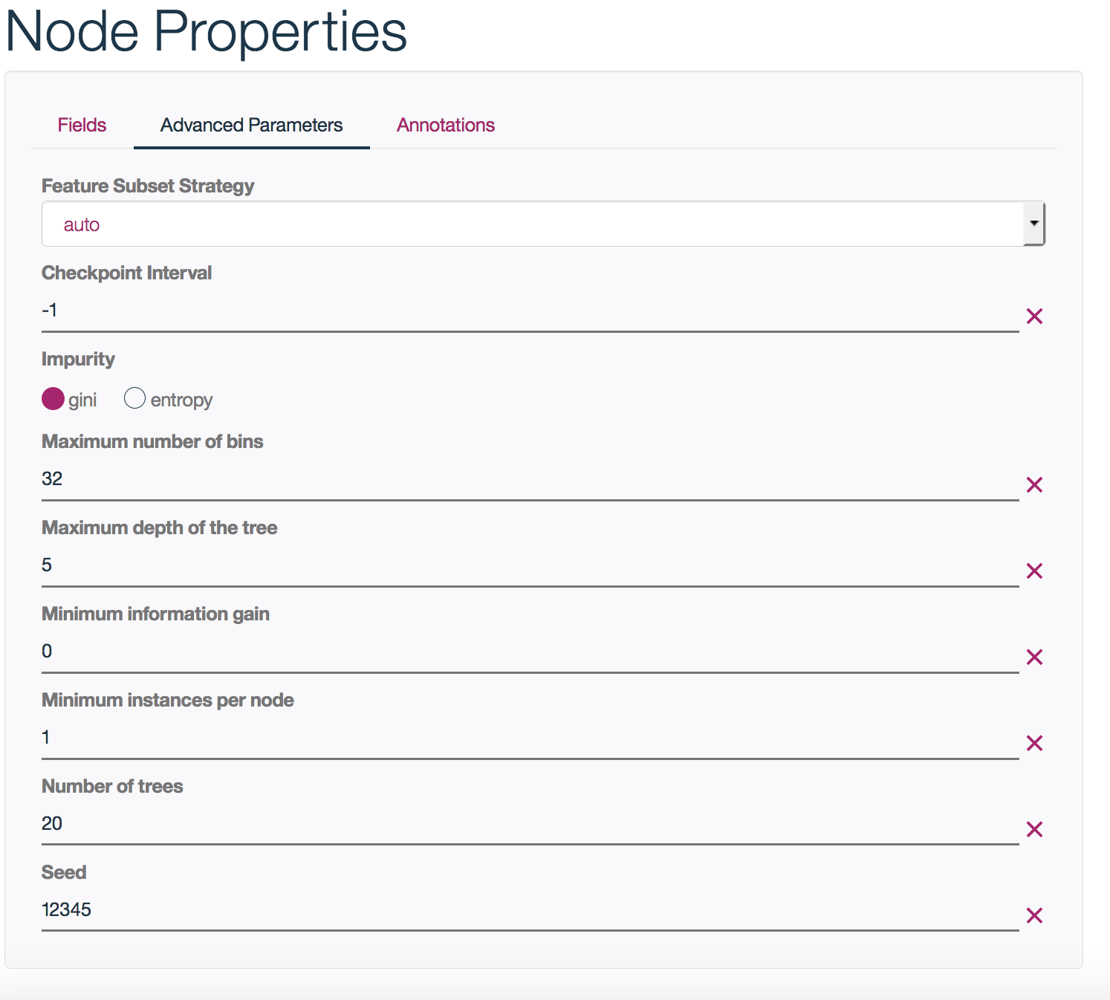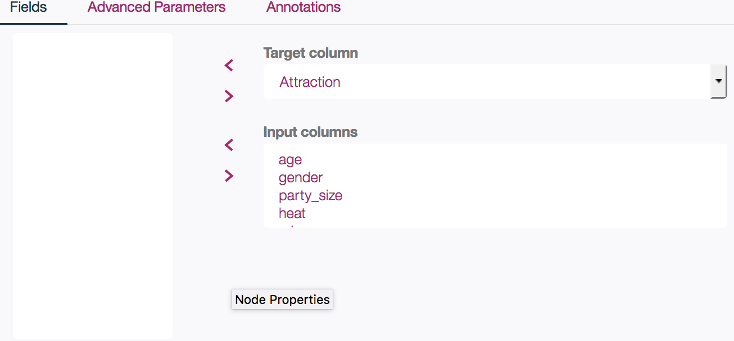Once the two nodes are connected (refer to above image), double click on the Random Forest node to set the target and input columns for our mode  
       
     - Like before, we will select the Attractions column as our target, and leave all the others as inputs  
       
       
       
       
       
       
       
       
       
       
     Note here, we are given more flexibility for building our models with ‘Advanced Parameters’  
       
       
       
       
       
       
       
       
       
       
       
       
       
       
       
       
       
     For example, here you can change the depth of the tree if you wanted (a higher value would be used for a more complex model, whereas a lower value would be used for a less complex model). For now, we will accept the defaults and click ‘Ok’.
  5. 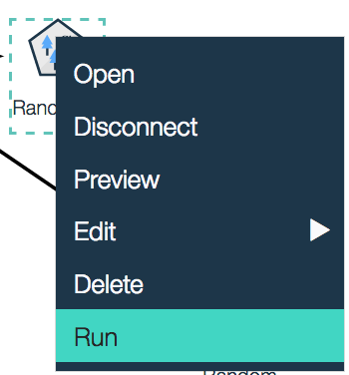Right click the Random Forest model node, and click ‘Run’   
       
       
       
       
       
       
       
       
       
     This may take a few minutes. When finished, you will see a blue model nugget appear. This is your trained model.
  6. To view the model, right-click the model nugget, and then click view model.

One of the hardest things in Machine Learning is to understand how a trained model will perform in production. With this model visualization component, you can immediately see which features have the most impact on your predictions with variable importance.

* 1. 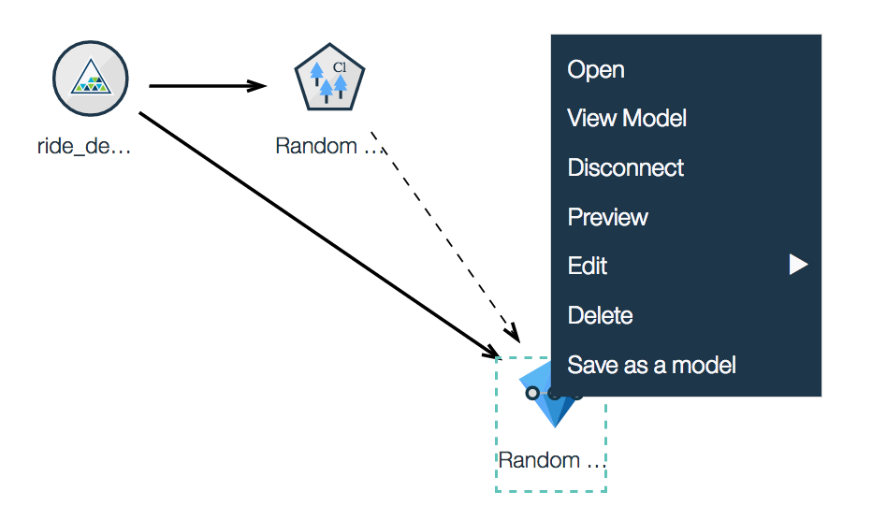To save the flow, right-click the model nugget node, click Save as a model, in the Model Name box type a name, and then click Save.  
       
       
       
       
       
       
       
       
       
       
       
       
       
       
       
       
     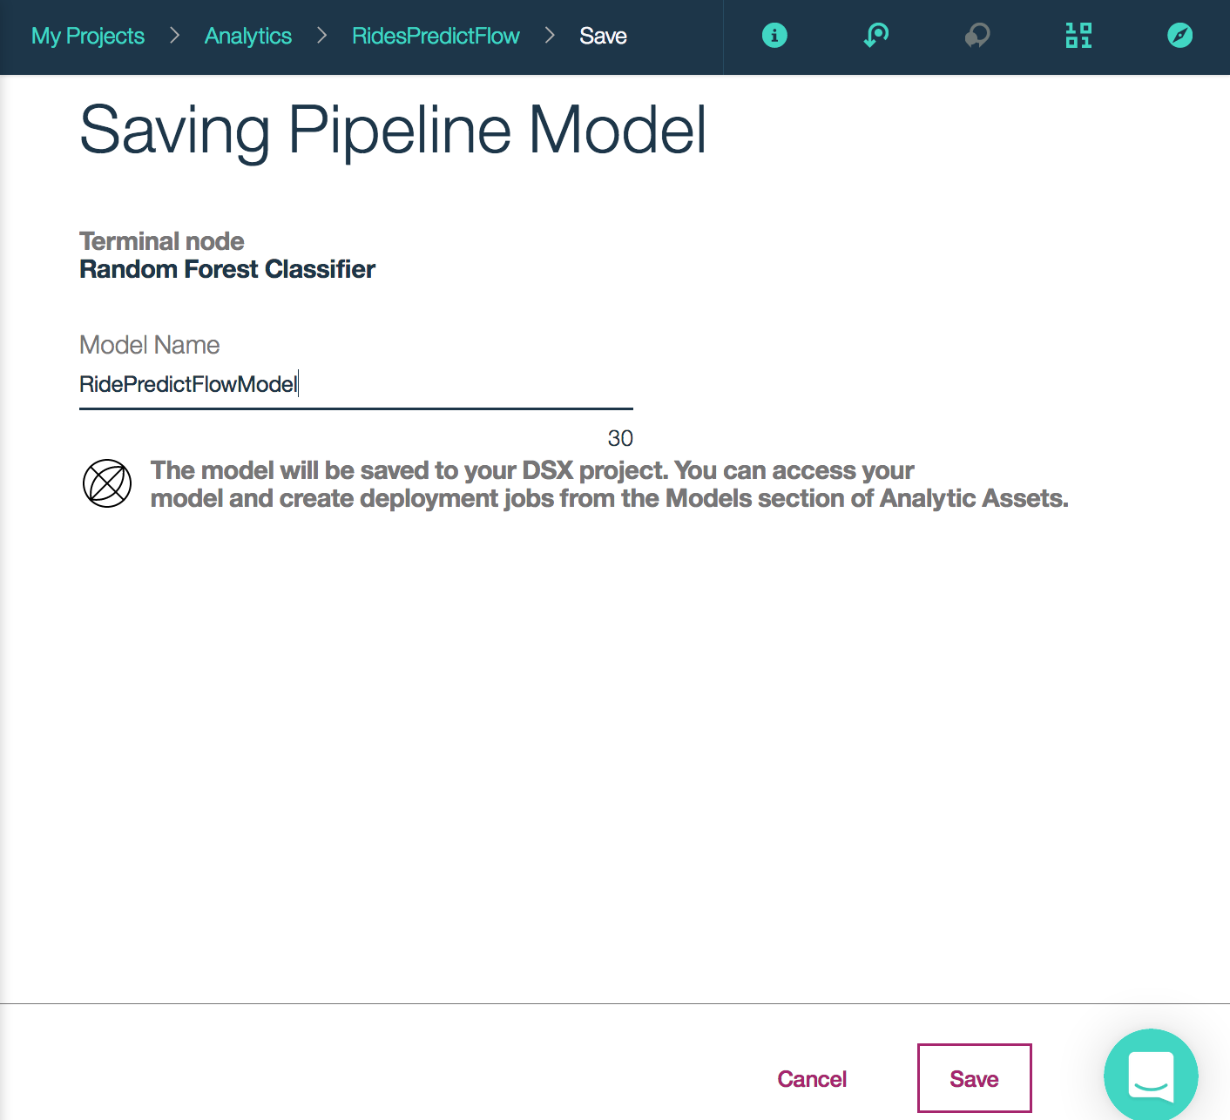
  2. 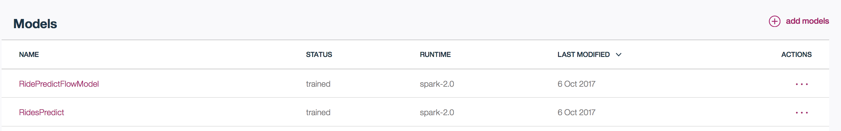To deploy the model, return to the ‘Analytics Assets’ tab of the project, click on the model created from the flow then click ‘Add Deployment’  
       
       
       
       
       
       
     From there, you would repeat steps k,l,m from earlier in the lab when we deployed the model we built in the automatic model builder.

**Summary**

Lab 2 introduces the Flow Editor in DSX for visual model building. Having that graphical representation of our data as we do transformations and model it is helpful for users to understand the flow. The Flow Editor is also compatible with SPSS Modeler streams for leveraging Watson Machine Learning.

**Lab 3 – Create a Random Forest Model with Python Notebook**

In labs 1 and 2, we were able to build and deploy working machine learning models from a CSV without writing any code. In this lab, we will explore the flexibility offered in a notebook environment for:

* Loading data from an external source (Object Storage)
* Doing basic data cleaning and exploration
* Pipeline creation
* Model training
* Model persistence to a Watson Machine Learning repository

A **Jupyter notebook** is a web-based environment for interactive computing. You can run small pieces of code that process your data, and you can immediately view the results of your computation. Notebooks include all of the building blocks you need to work with data:

* The data
* The code computations that process the data
* Visualizations of the results
* Text and rich media to enhance understanding

The dataset we are loading in is a ‘movies’ dataset which contains service subscriber data and movies streamed. For this lab, we are using the data to create a random forest model that can help us predict which movies to suggest to future subscribers. The ability for a company to provide tailored recommendations can help reduce customer churn, increase customer satisfaction and ultimately drive revenue.

**Lab duration**: 60min

**Audience**: Data Scientist

**Capabilities**: DSX User Interface, Python scripting, Spark, Watson Machine Learning

**Prerequisites**: Labs 0-2. Basic knowledge of Python might be helpful.

1. Select the ‘Assets’ tab and click ‘New Notebook’

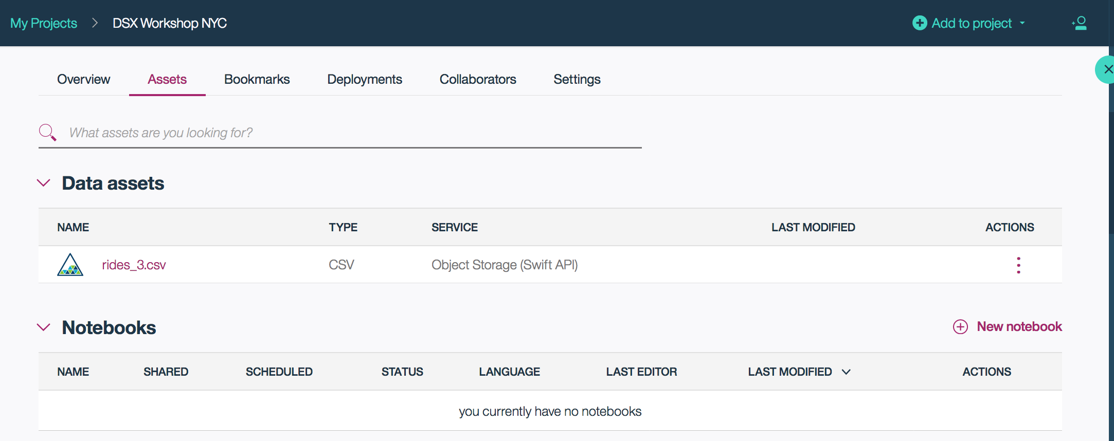

1. 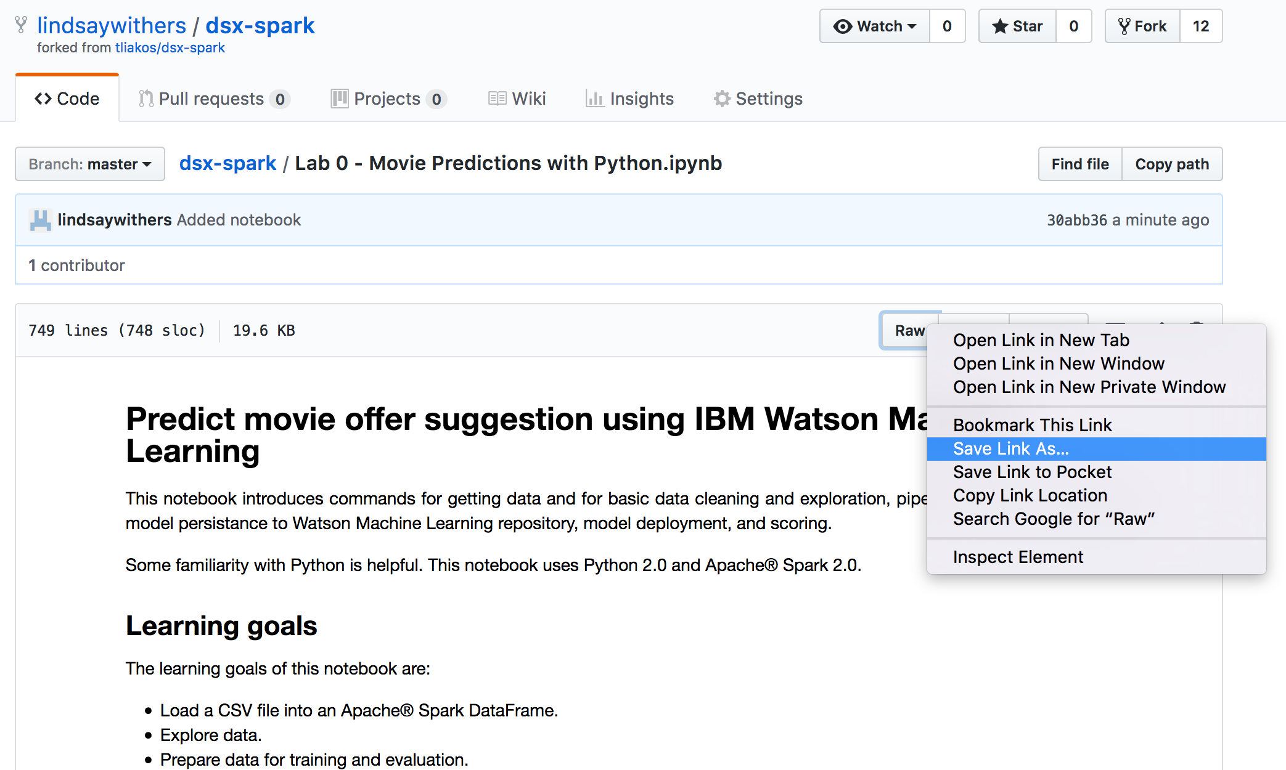Open a new tab and navigate to the Github Repository which has all the files for this workshop (<https://github.com/lindsaywithers/dsx-spark>)  
     
   - Click on the ‘Lab 0 – Movie Predictions with Python.ipynb’ file  
   - Right click ‘Raw’ and save the notebook file to your desktop (‘Save Link As’)
2. Switch back to Data Science Experience in your browser. Give the Notebook a name and click Choose File. Navigate to the location where you downloaded the ‘Lab 0 – Movie Predictions with Python.ipynb’ file from the lab materials and click open, then click Create Notebook at the bottom of the screen.

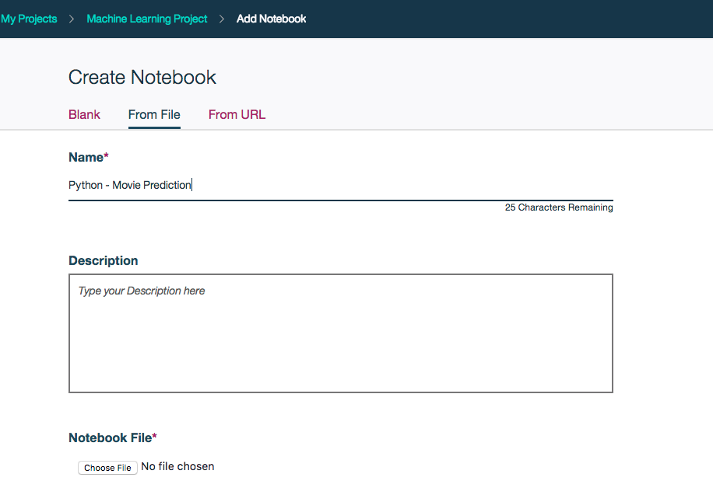

1. 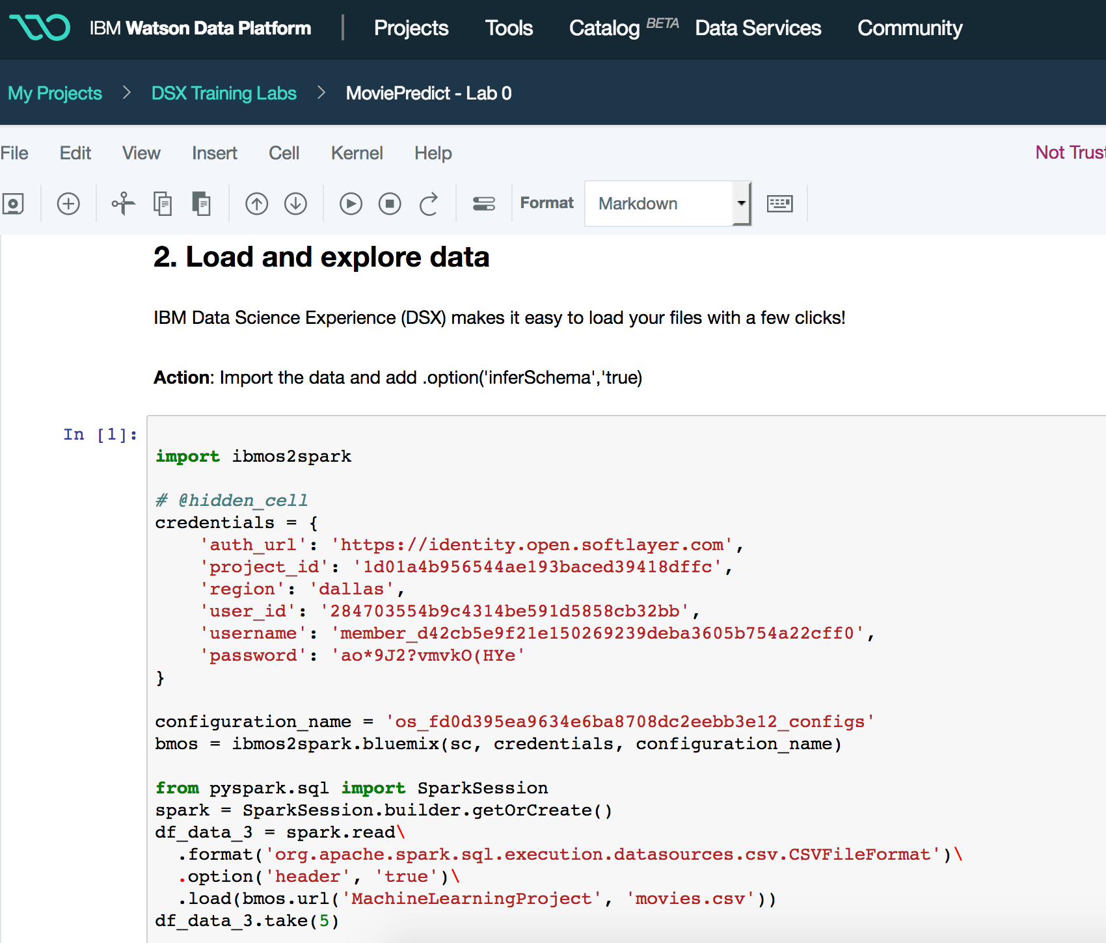After the notebook loads, scroll down to the first empty code block (Under 2. Load and explore data). Here we are establishing a connection to Object Storage where a dataset of movies and subscriber data resides, and we are loading the data in. Click anywhere inside the cell, and press the play button to execute the code.
2. 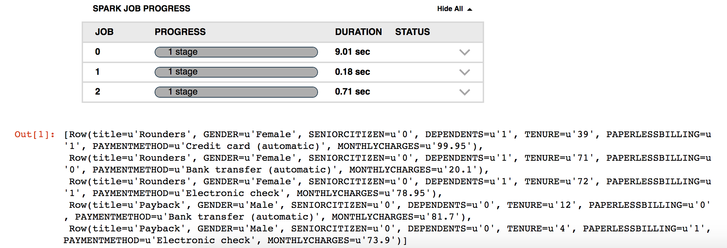You will see the node is running while the line number shows [*]. You will also notice the Spark Job processing, and the status of each stage. Once the data has been loaded in, you should see an output with 5 sample records of the data.
3. Once complete look at the df_data_x = spark.read line. In the example below the value is df_data_3. That value needs to be added to the next code block as shown below. Then run that code block (Ctrl+enter or play).

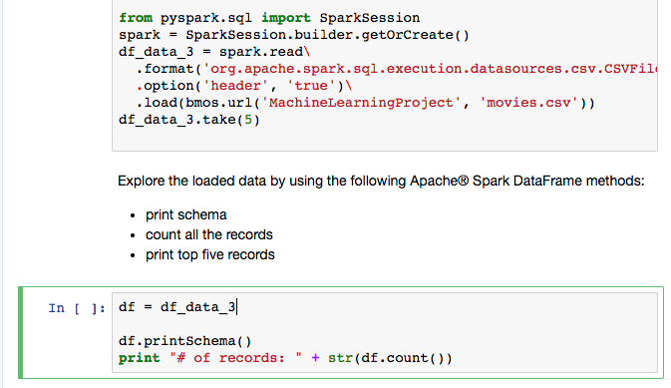

1. When you get to section 4. Persist model in IBM Watson Machine Learning you will see a line over the second code block that reads:

**Action**: Use your Watson Machine Learning service instance credentials below.

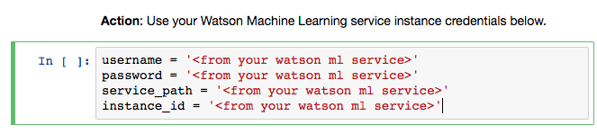*You will need to input your Watson Machine Learning credentials before executing this code block. To do this return to IBM Cloud (<https://console.ng.bluemix.net/>)

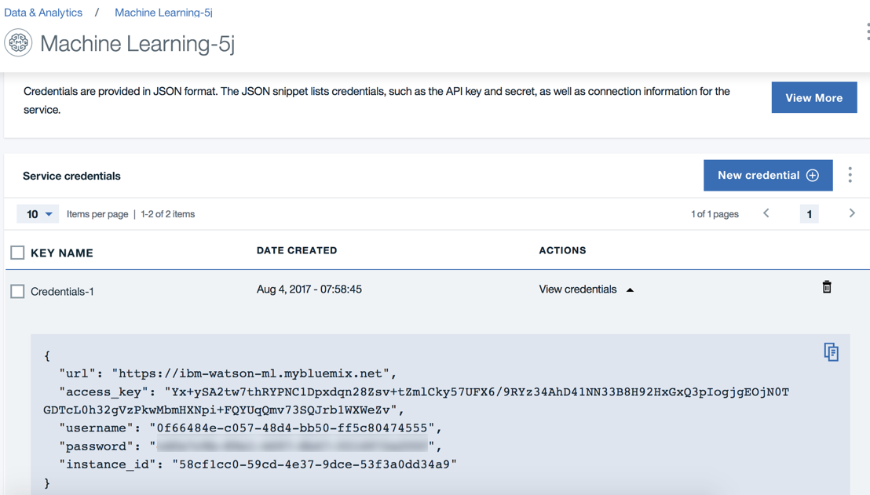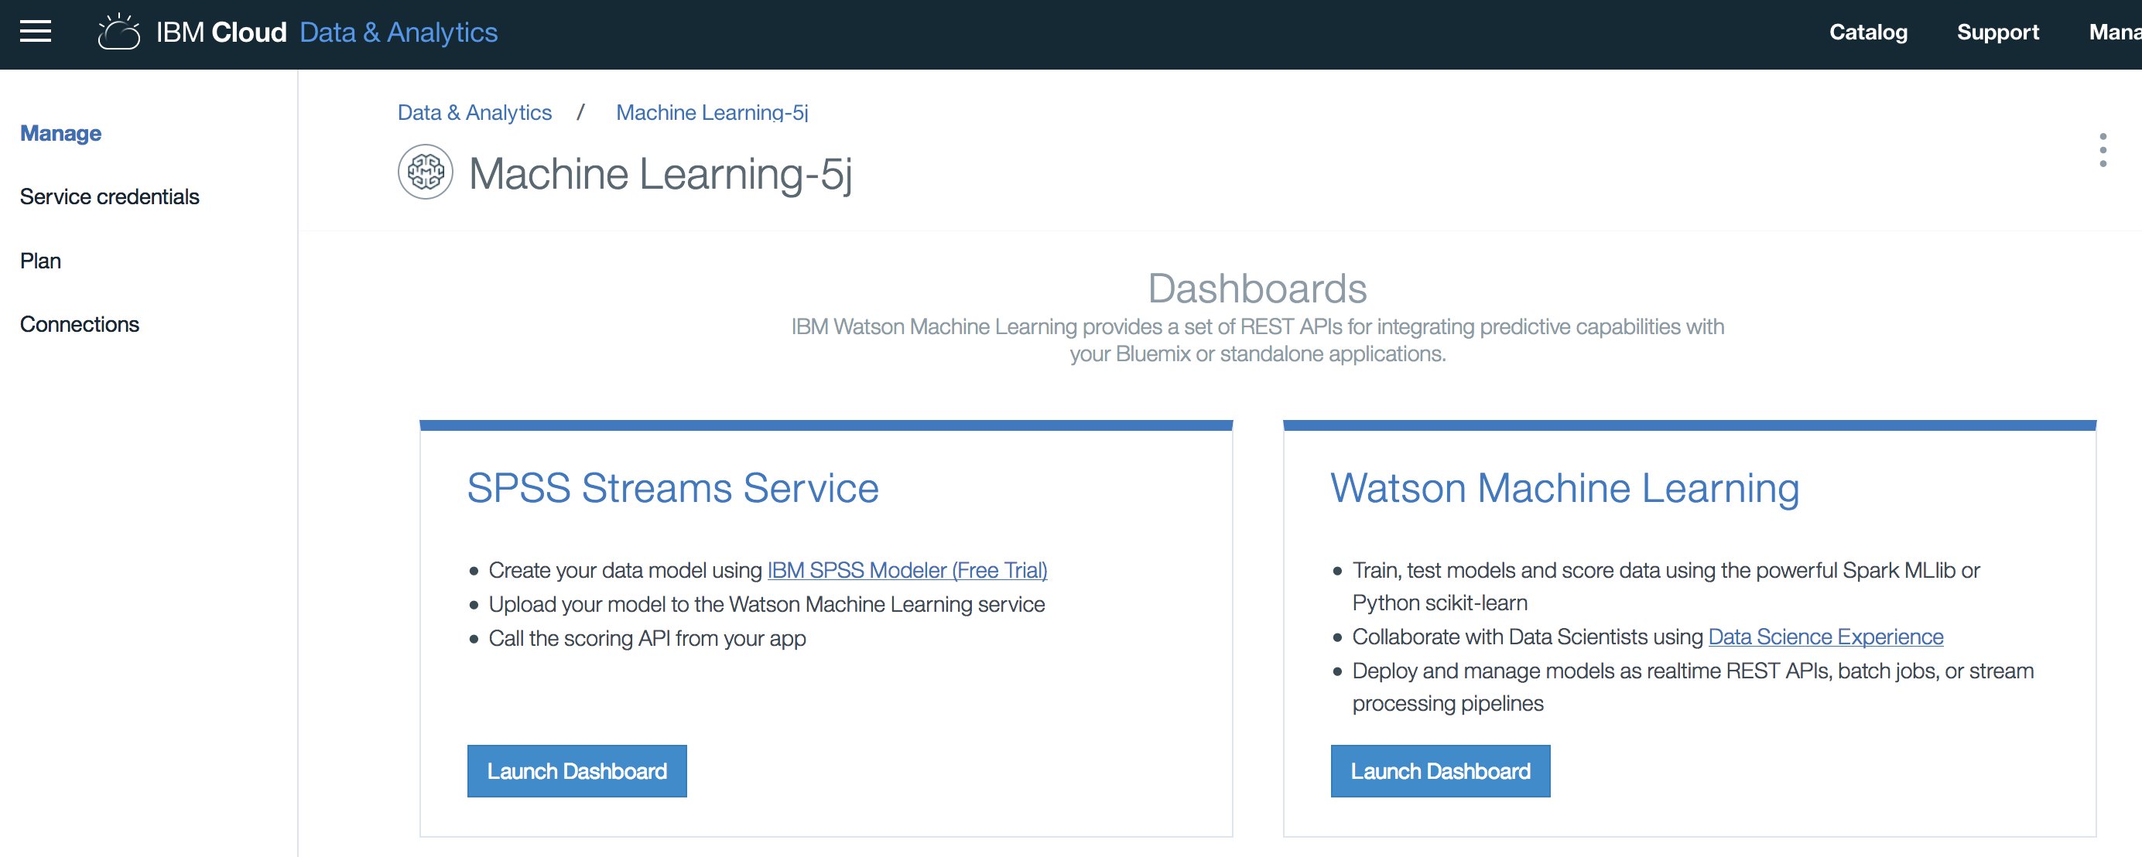- Navigate to the Watson Machine Learning service that you created earlier to grab the service credentials to update the values in the cell.   
  
  
  
  
  
  
  
  
  
  
  
  
  
- You’ll need the username, password, url (which will be the service_path) and instance_id

1. Continue to execute each code block and follow the documentation in the notebook to understand what each code block is doing.

**Summary**

Leveraging the power of Jupyter Notebooks inside of DSX allows data scientists to work in the environment of their choice, using their favorite open source libraries and packages. With these being integrated with projects, the data science team is able to collaborate and share compute resources.

**Lab 4 – Introduction to SparkSQL**

[Apache Spark™](http://spark.apache.org/) is an Open Source, general-purpose, data processing engine designed to be fast, easy to use, and flexible enough to run in any environment. Application developers and data scientists incorporate Spark into their applications to rapidly query, analyze, and transform data at scale. Tasks most frequently associated with Spark include interactive queries across large data sets, processing and streaming data from sensors or financial systems, and machine learning tasks.

In Data Science Experience, you can use Spark for your Python, Scala, or R notebooks.

Spark SQL is one of the most widely used Spark libraries that introduces a new data abstraction called SchemaRDD, which provides support for structured and semi-structured data. Spark SQL lets you query structured data inside Spark programs using either SQL or the DataFrame API.

DSX has many preinstalled libraries for Python and R, for example, **SparkSQL**, Spark Streaming, Spark MLlib, GraphX, and Brunel visualization libraries.

In Lab 3 you’ll explore how to leverage Spark to build *SQL* queries in a Python notebook.

**Lab duration**: 60-90min

**Audience**: Data Scientist, Data Engineer, Business Analyst, SQL users

**Capabilities**: DSX User Interface, Python scripting, Spark

**Prerequisites**: Labs 0-3. Basic knowledge of Python/SQL might be helpful.

1. Navigate back to the ‘Assets’ tab of your project in DSX
2. Click ‘New Notebook’  
   1. Click ‘add notebooks’ to add our Spark SQL notebook
   2. 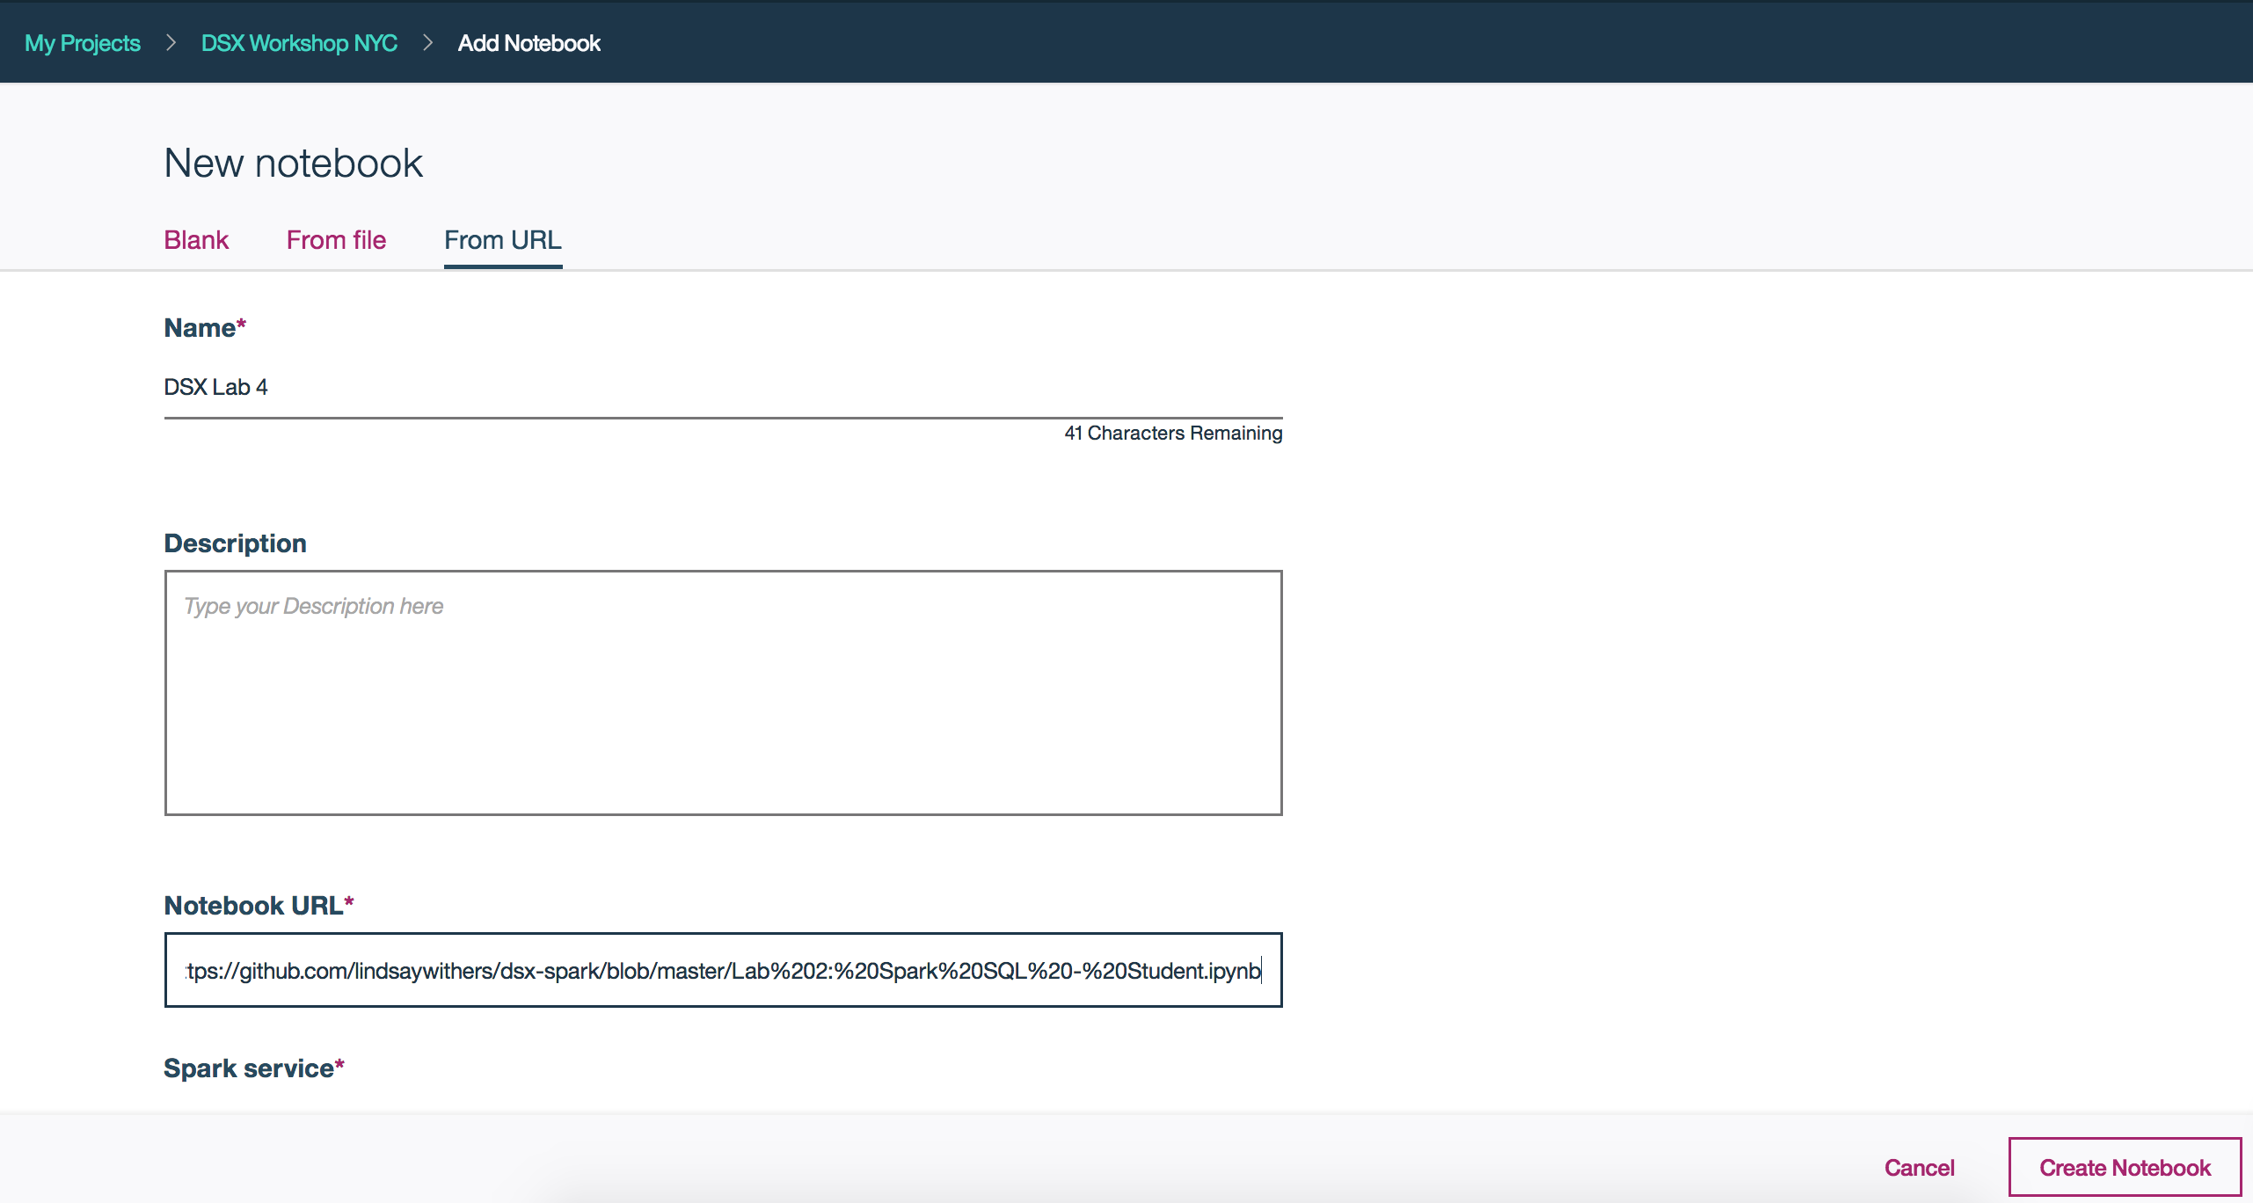Click ‘From URL’, give your notebook a name, and drop the following URL: <https://github.com/lindsaywithers/dsx-spark/blob/master/Lab%202:%20Spark%20SQL%20-%20Student.ipynb>  
        
      - Once ready, click ‘Create Notebook’
   3. 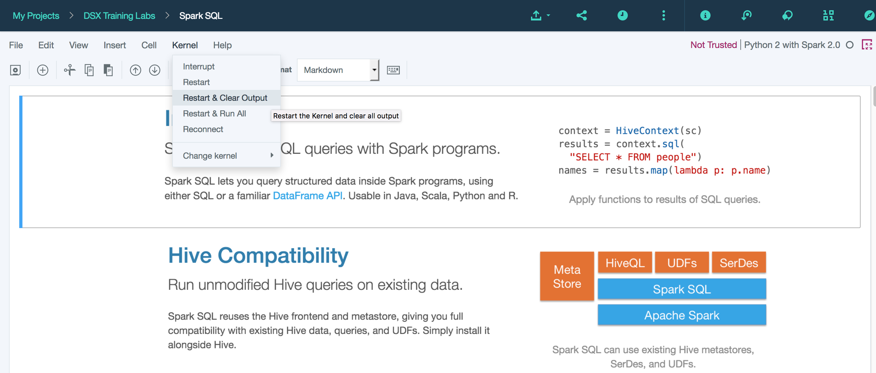Once the notebook is loaded, click ‘Kernal’ and click ‘Restart & Clear Output’
   4. Follow the instructions in the Python notebook to get started working with Spark SQL  
        
      - Notice there are hints throughout and optional steps for your learning purposes  
      - Refer to the instructor notebook for answers if needed:  
      <https://github.com/lindsaywithers/dsx-spark/blob/master/Lab%202:%20Spark%20SQL%20-%20Instructor.ipynb>

**Summary**

This section continued our learning of the functionality we get from running Spark programs in DSX. Here, users learned how to create Dataframes – and how they differ from RDDs. With Dataframes, we can query using Spark SQL. This lab also gave users a chance to work with Pandas and Seaborn for data visualization. The ability to combine SQL queries with the speed of Spark significantly reduces the time to value in any data science initiative – getting you to your insights faster.